**Practical Task 1: Deploy a Docker Container to Azure Container Instances (ACI) via Azure**

**Portal**

**Requirements:**

1. Create a lightweight Docker image for a simple web application (e.g., a Python Flask app)

with minimal dependencies to reduce resource usage.

2. Push the Docker image to Azure Container Registry (ACR) using a low-cost storage option.

3. Use a lightweight ACI instance (e.g., B1s) to deploy the Docker container from ACR.

4. Verify the deployment by accessing the web application via the public IP address provided

by ACI.

1. Remove the ACI container after verifying the deployment to stop billing.

### ****Actions Taken:****

1.Created a Docker image for a Java web application and pushed by docker

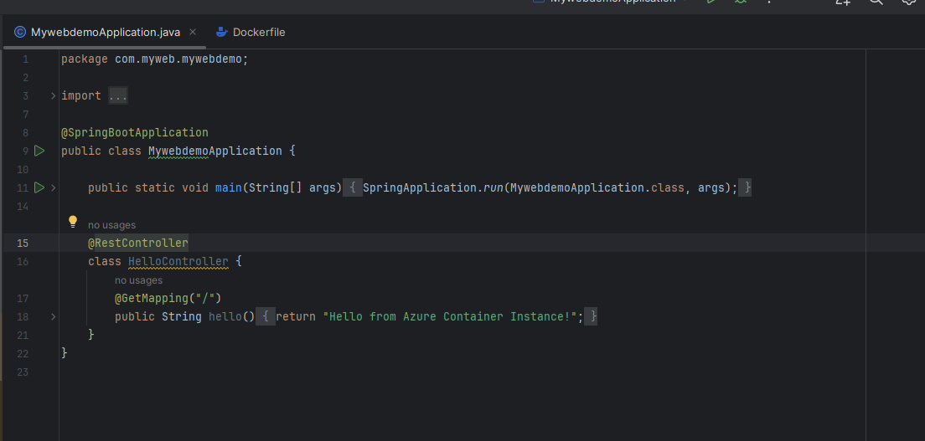

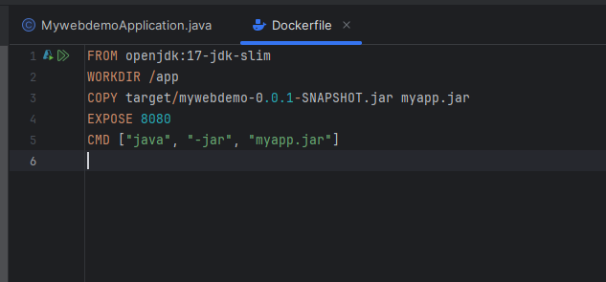

2.Created ACR with name myjavaapp

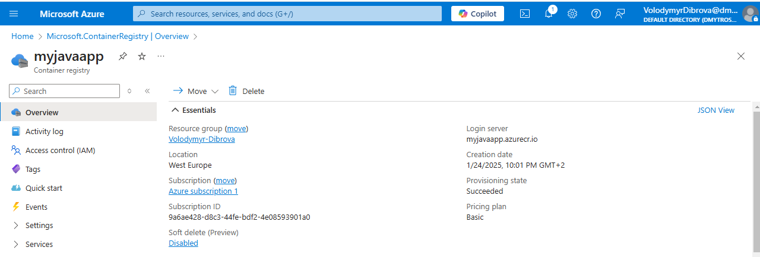

3.Created ACI with name myjavaapp

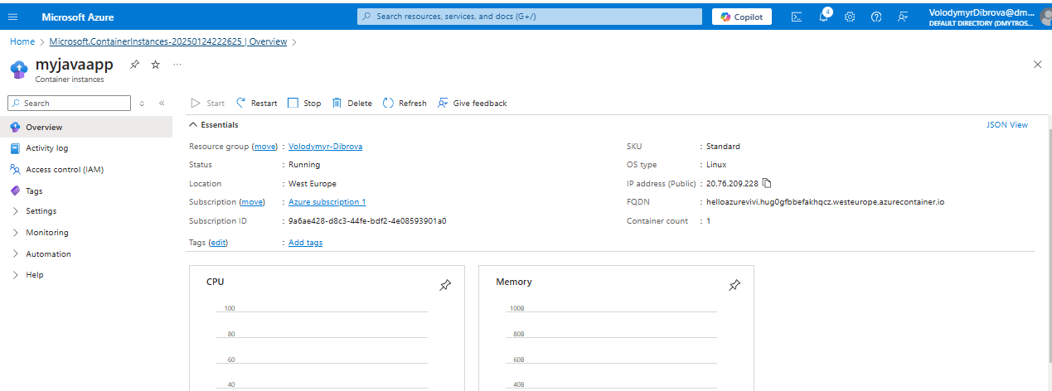

4.Tested in browser by public IP address

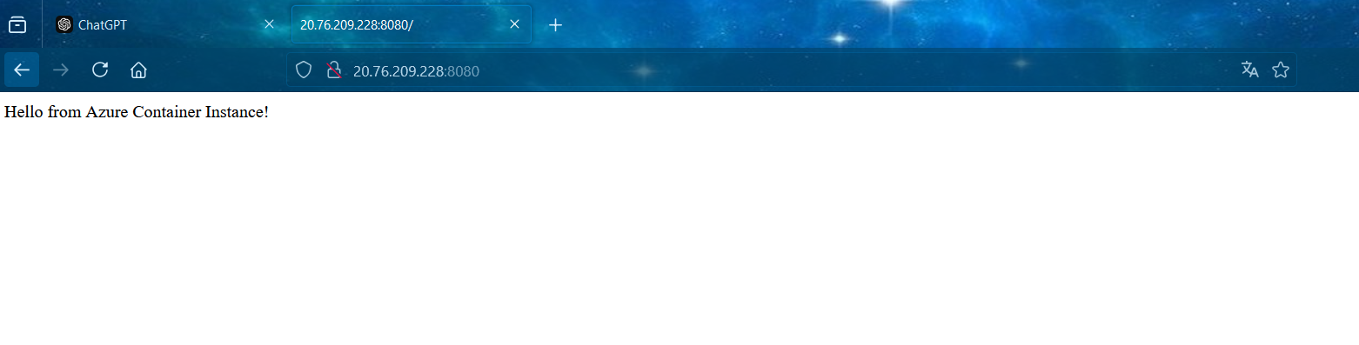

**Practical Task 2: Configure Environment Variables in ACI via Azure Portal**

**Requirements:**

1. Modify your Docker image to read configuration values from environment variables,

ensuring minimal environmental complexity.

2. Reuse the ACI instance from Task 1 to deploy the container and specify the necessary

environment variables.

3. Verify that the application is correctly using the environment variables by checking its

output.

4. Remove the ACI container after verifying that the application correctly uses the

environment variables.

****Actions Taken:****

1.Modified the Docker image to work with environment variables and pushed by docker

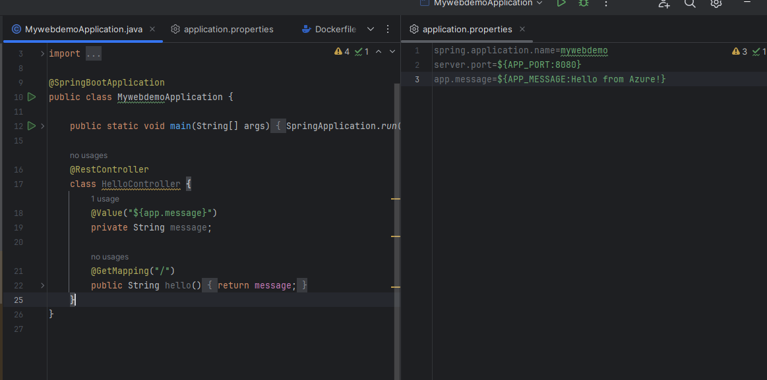

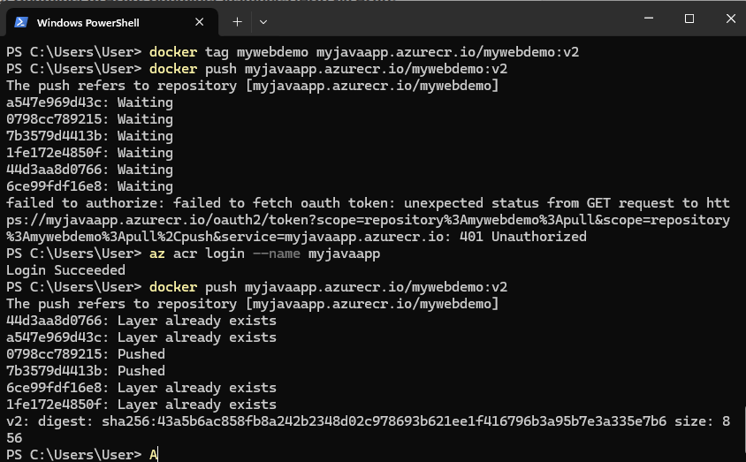

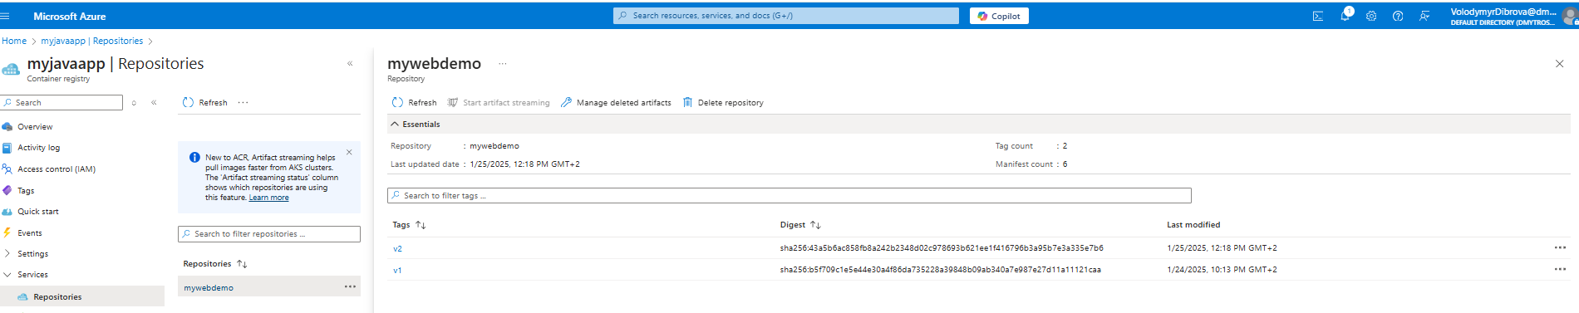

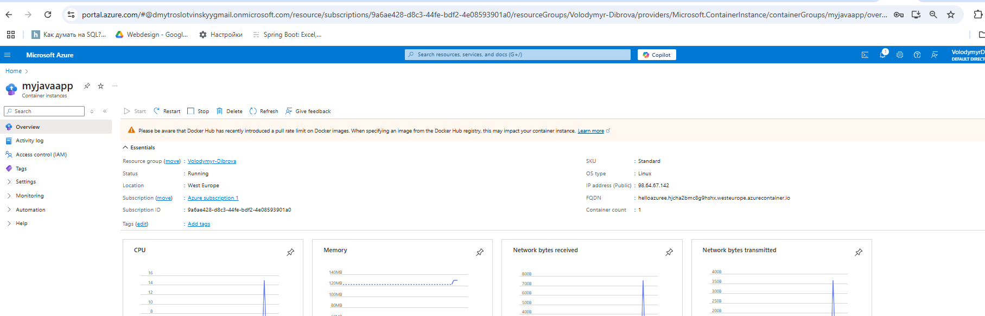

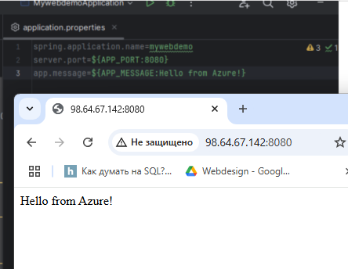

**Practical Task 3: Scale Out with Azure Container Instances via Azure Portal**

**Requirements:**

1. Deploy a stateless Docker container to Azure Container Instances using a lightweight

configuration (e.g., B1s instances).

2. Manually scale out to the minimum number of instances required (e.g., 2–3) to test load

distribution.

3. Stop all ACI instances after completing the testing to reduce ongoing costs.

****Actions Taken:****

**First option: Without ACI**

1.Created 3 containers in ACR

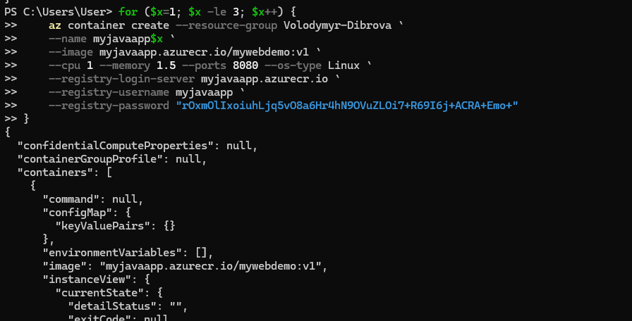

2.Checked logs for 3 containers

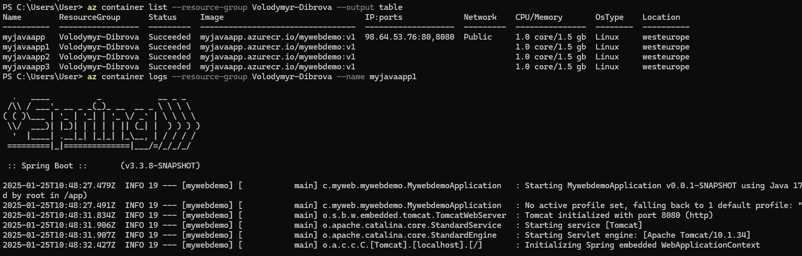

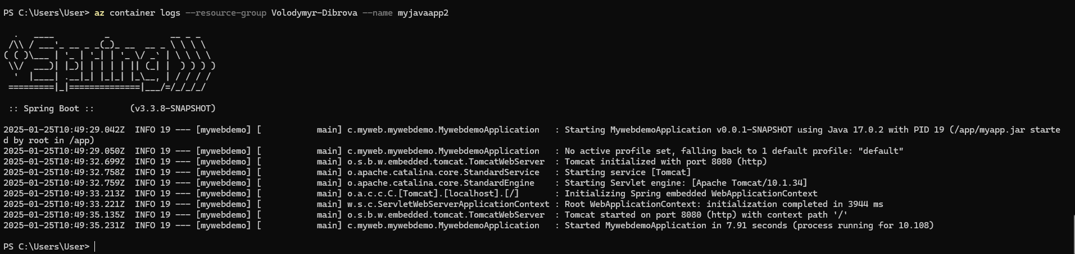

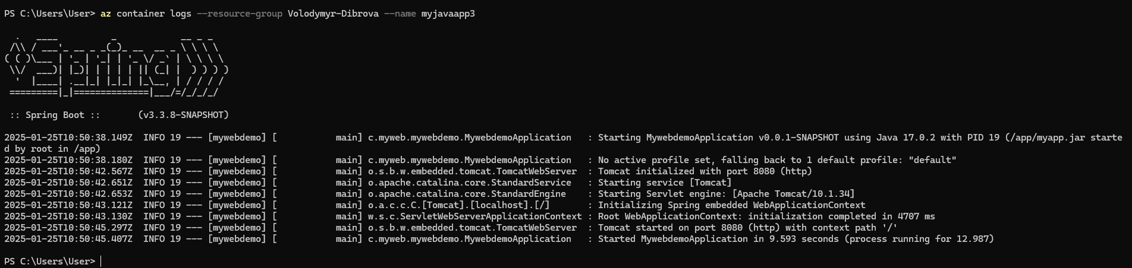

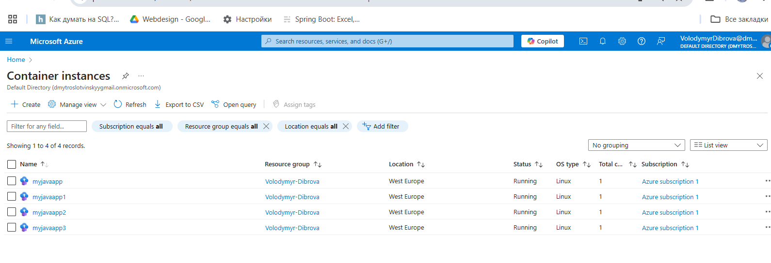

3.Tested in browser

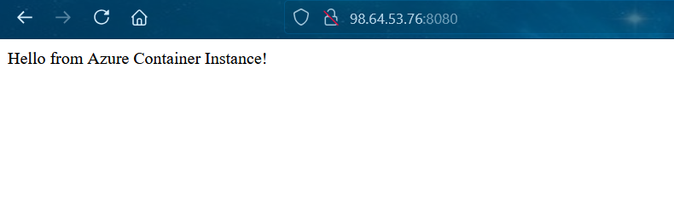

**Second option: with ACI**

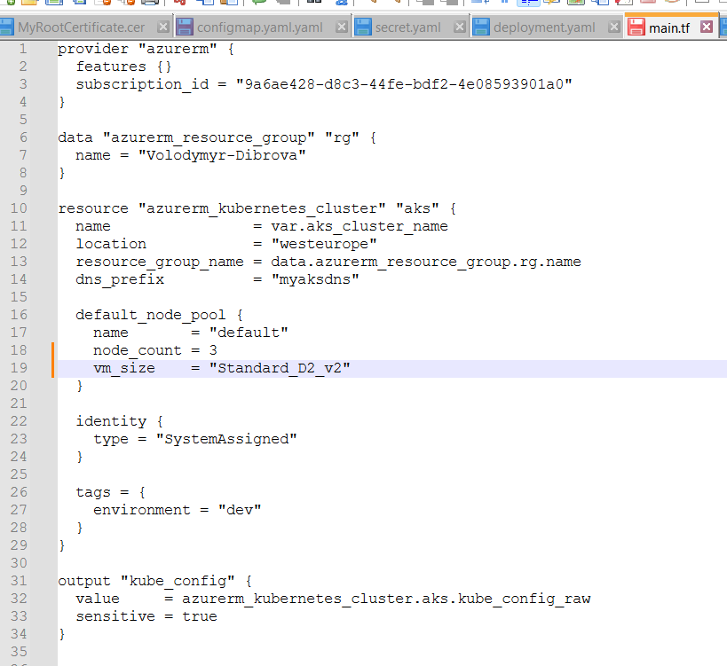

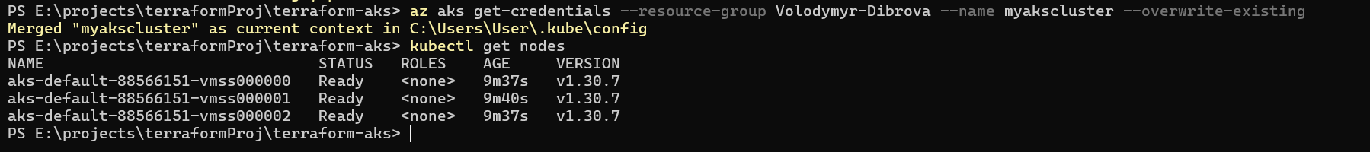

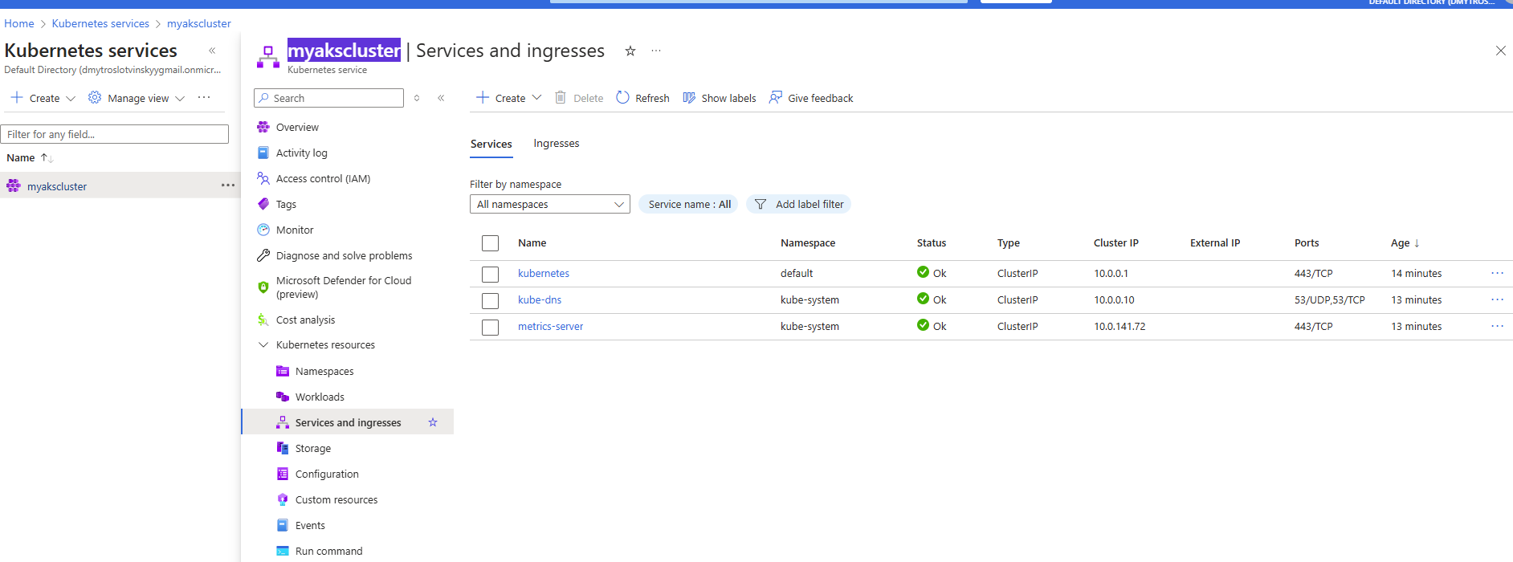

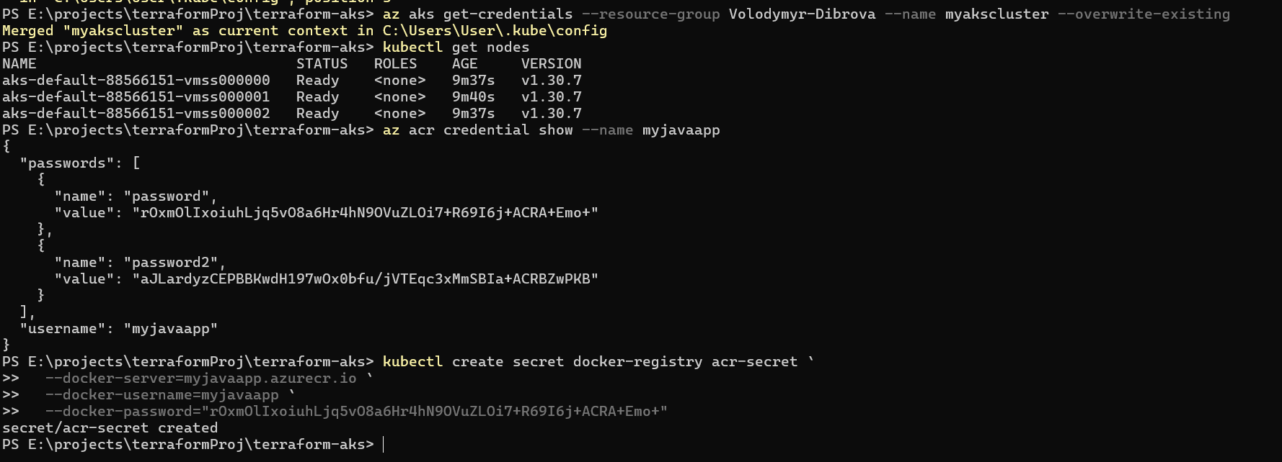

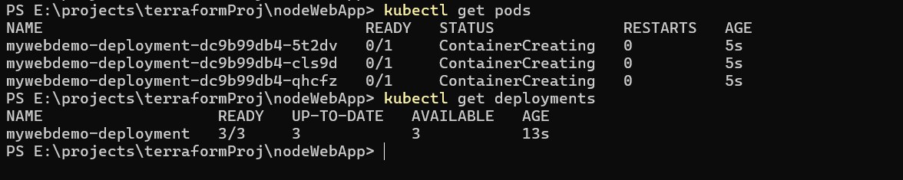

Logs for every containers:

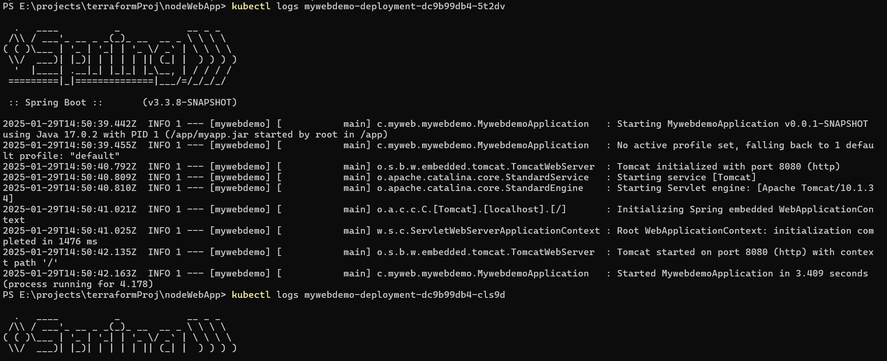

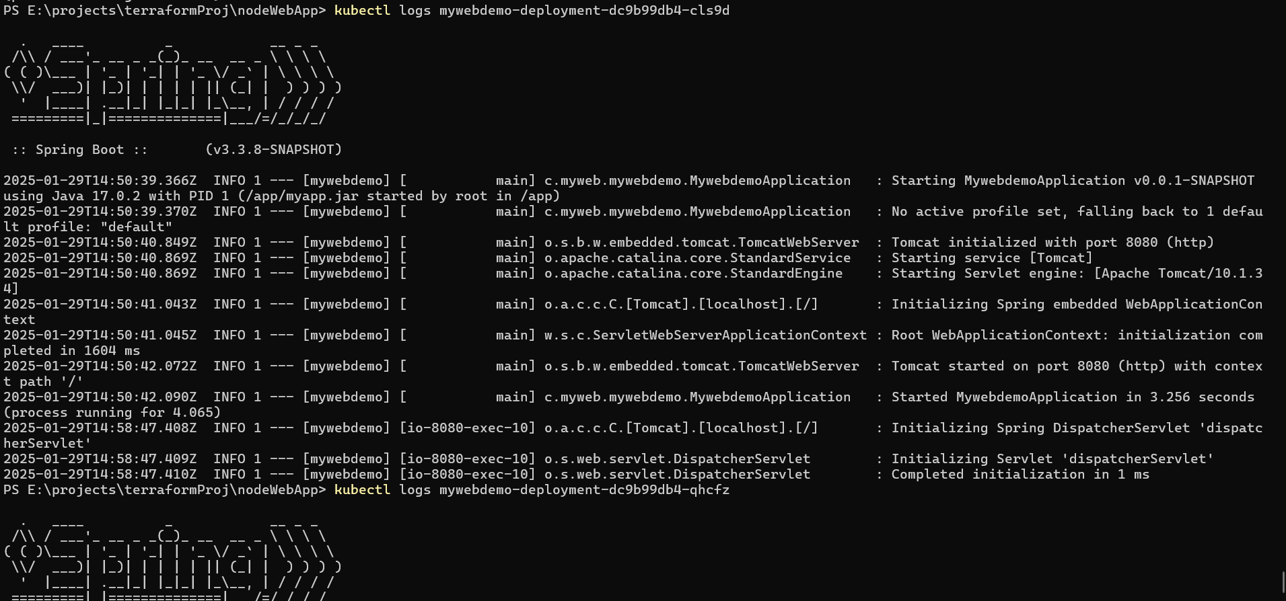

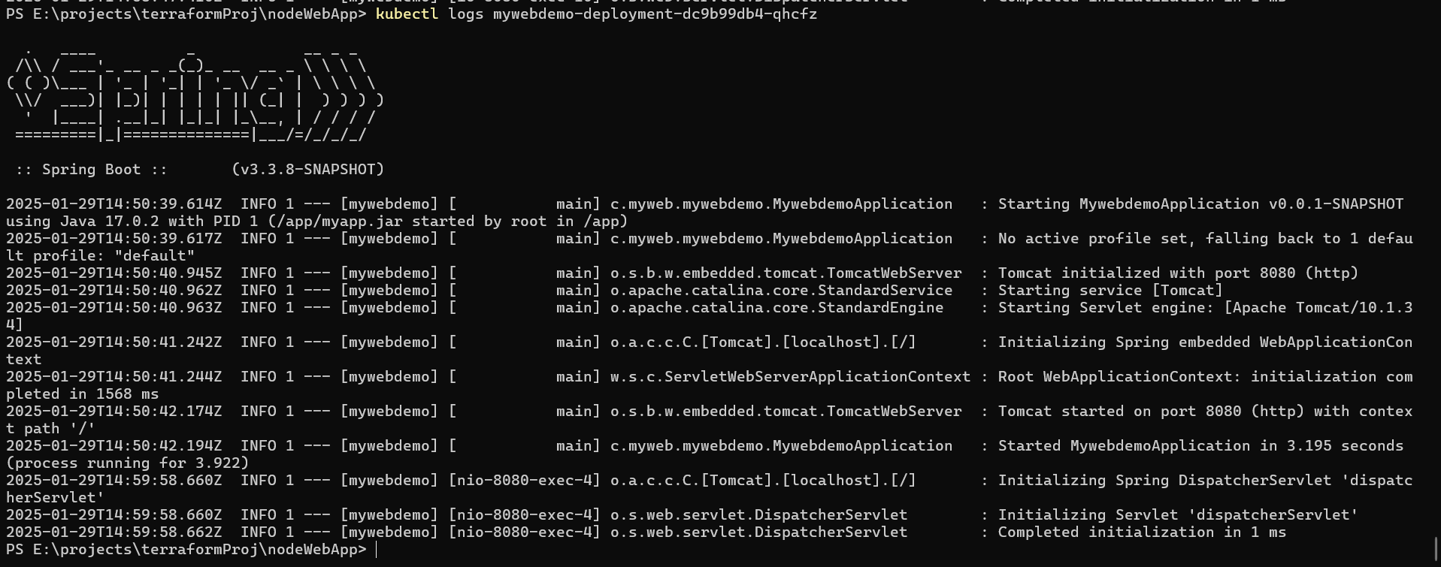

**Check load balancing between 3 pods**

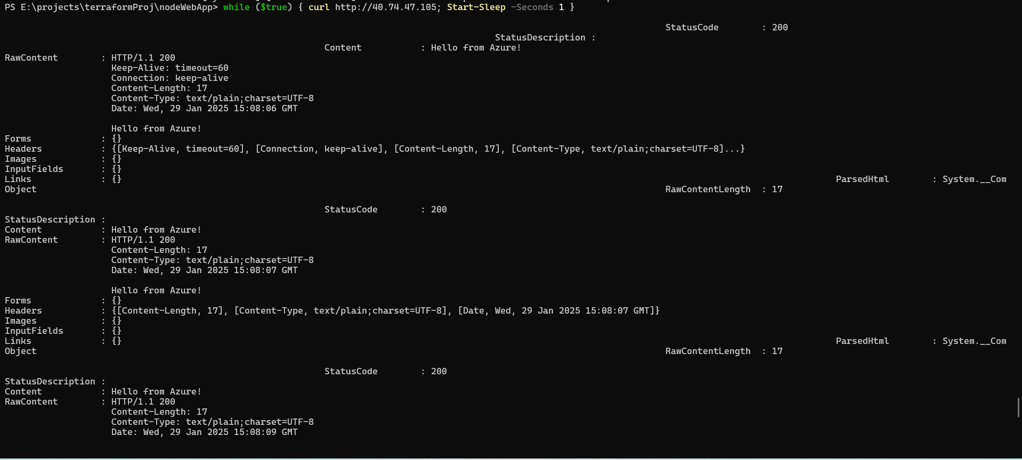

**Practical Task 4: Secure a Docker Container in ACI with Managed Identity via Azure Portal**

**Requirements:**

1. Deploy a Docker container to Azure Container Instances using the existing lightweight ACI

setup from previous tasks.

2. Configure a Managed Identity for the ACI and securely access an Azure service (e.g., Azure

Key Vault) with minimal permissions and access scope.

3. Retrieve only a single secret from Azure Key Vault for testing purposes.

4. Remove the ACI container after verifying secure access.

****Actions Taken:****

****1.Created app for getting Secret from Azure****

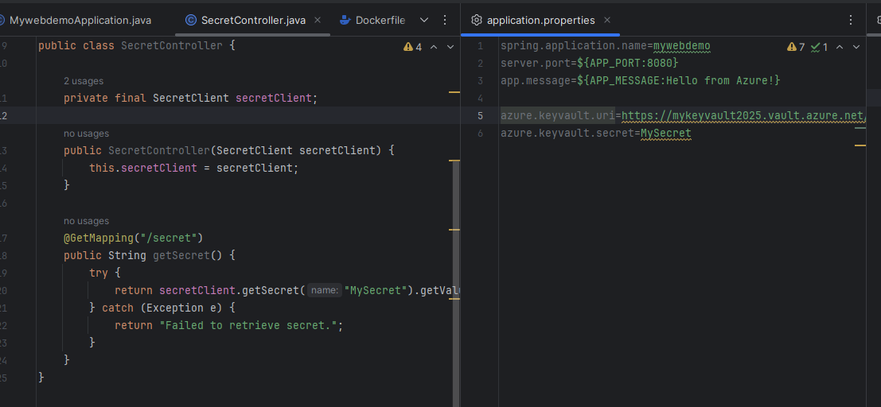

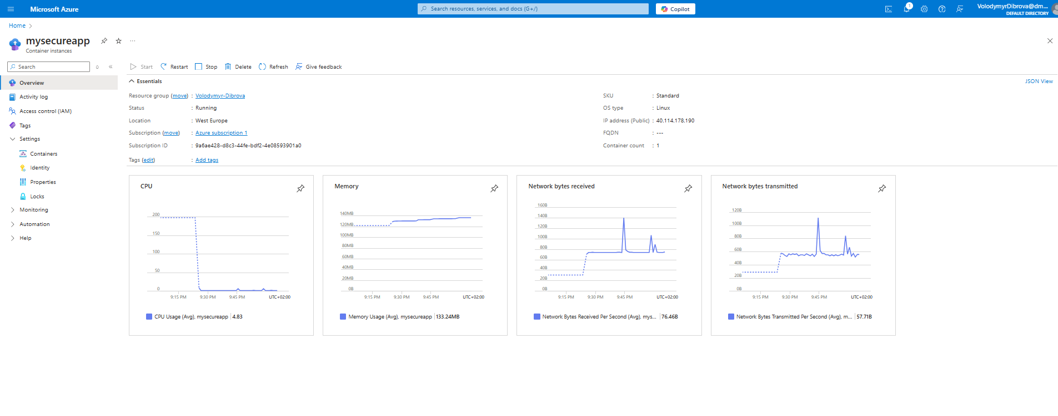

2.Created Key Vault and added Role Assignment (**K**ey Vault Administrator)

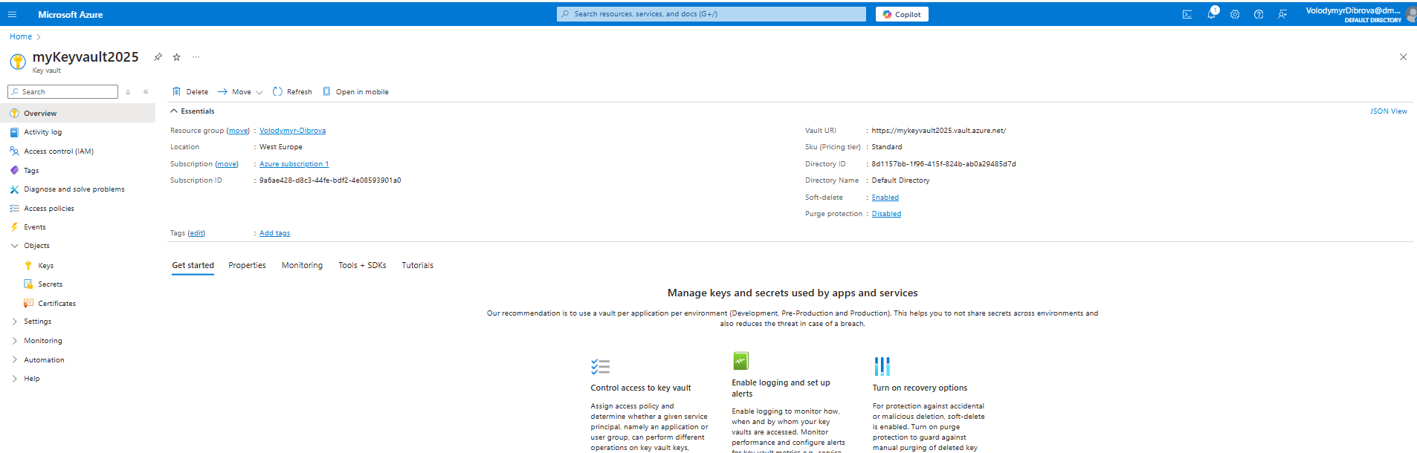

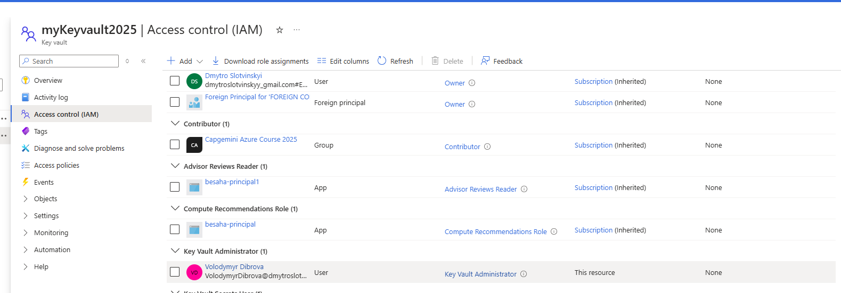

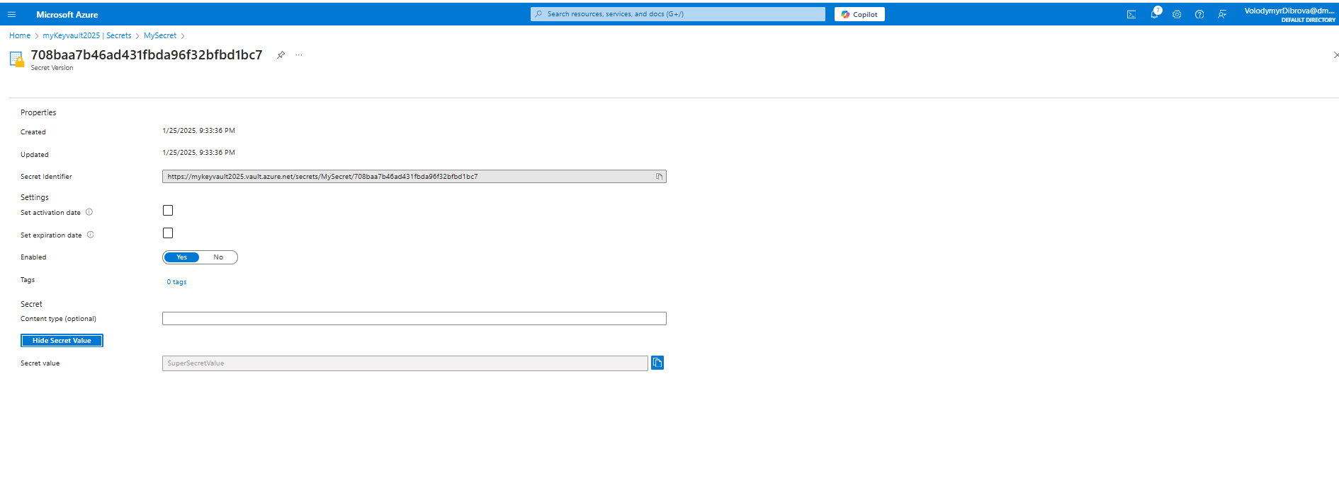

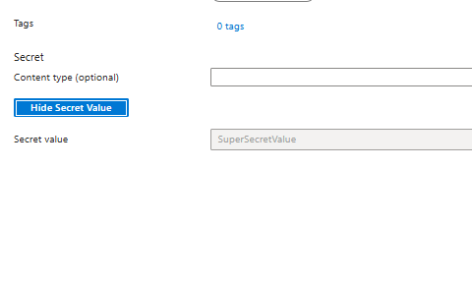

deployed v3 in mywebdemo

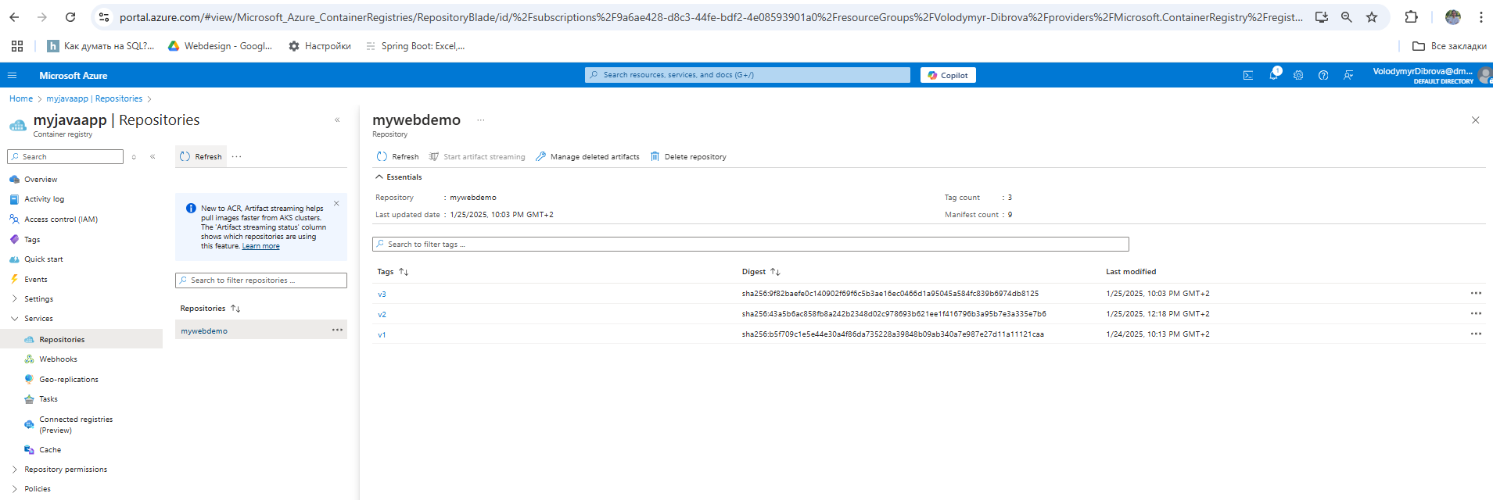

Tested in browser by v3 - retrieved secret



**Practical Task 5: Deploy a Kubernetes Cluster with AKS via Azure Portal**

**Requirements:**

1. Create an Azure Kubernetes Service (AKS) cluster with the smallest VM size (e.g., B2s) and

the minimum number of nodes (e.g., 1–2).

2. Connect to the AKS cluster using Azure Cloud Shell with kubectl.

3. Deploy a lightweight Nginx application for verification.

4. Delete the AKS cluster immediately after testing to avoid additional VM and cluster

****Actions Taken:****

1.created cluster using Terraform

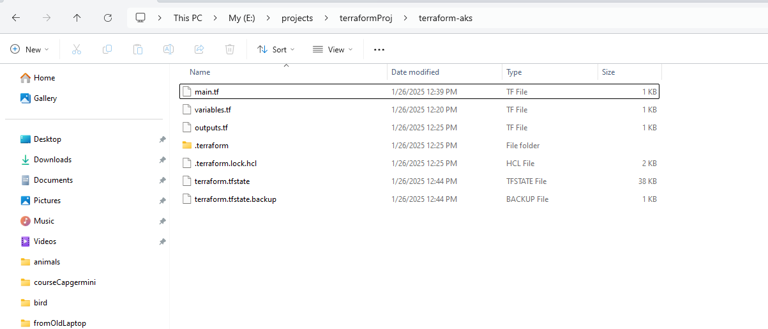

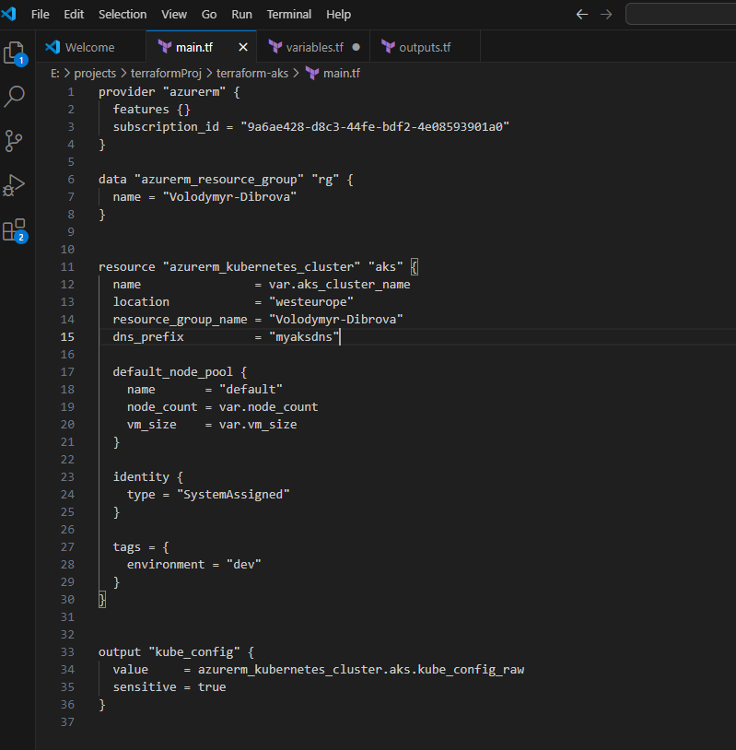

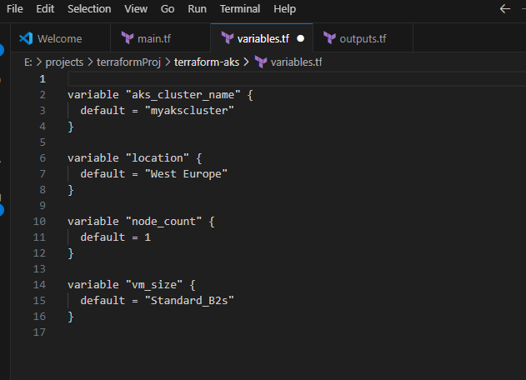

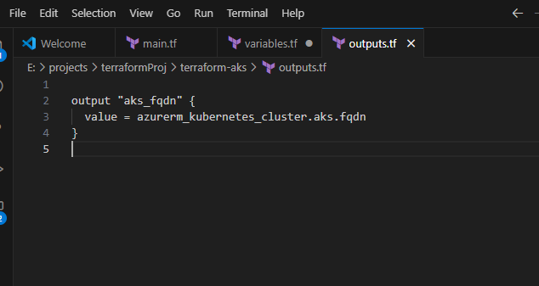

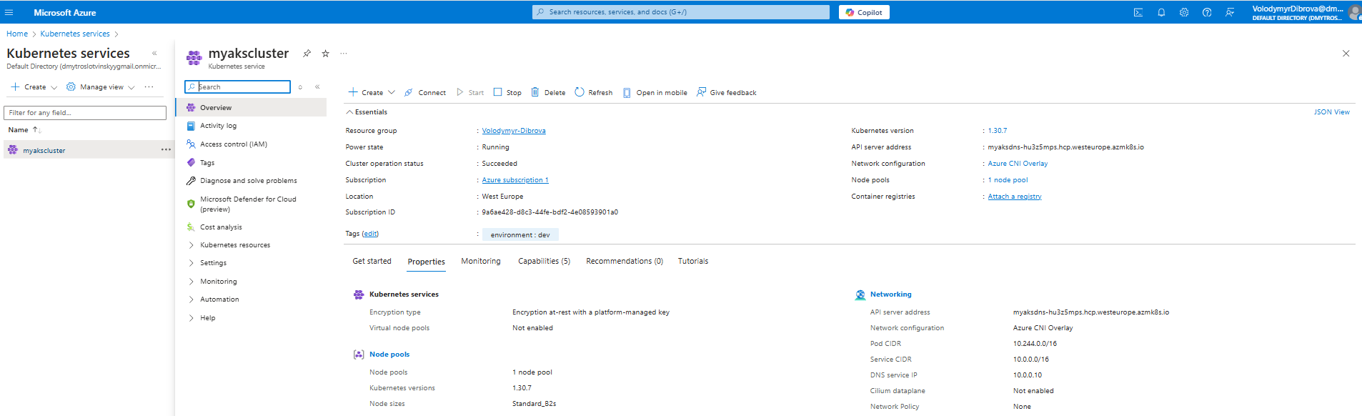

Successfully connected

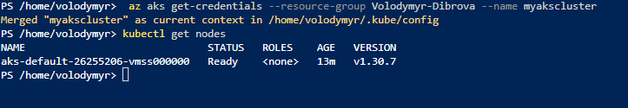

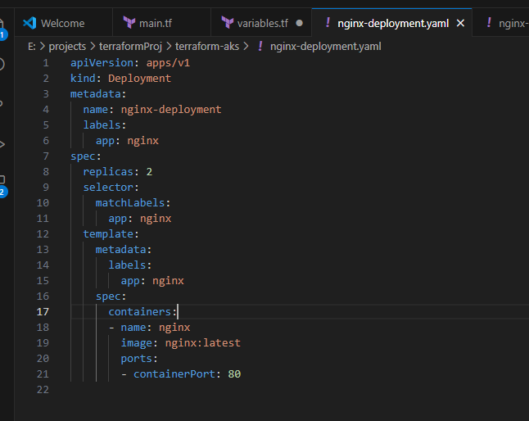

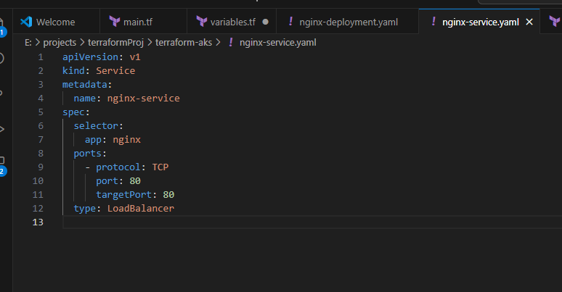

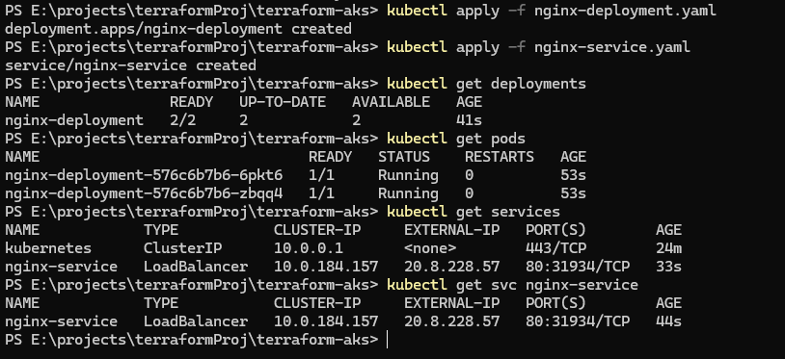

**Nginx Deployment:**

Name: nginx-deployment

Status: Both pods (2/2) are **running correctly**

Age: 41 seconds.

**Pods (containers):**

Both pods are running (Running)

Age: 53 seconds.

**Nginx Service:**

Type: LoadBalancer

Internal IP (CLUSTER-IP): 10.0.184.157

External IP (EXTERNAL-IP): **20.8.228.57**

Port: 80:31934/TCP

Age: 44 seconds.

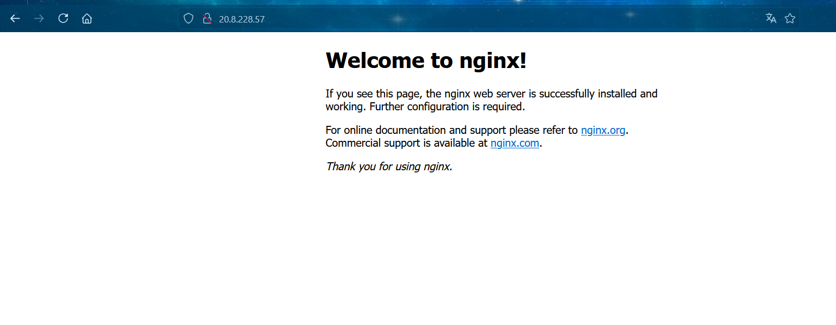

**Practical Task 6: Deploy a Containerized Application on AKS**

**Requirements:**

1. Build a lightweight Docker image for a simple web application (e.g., a Node.js app with

minimal dependencies) and push it to Azure Container Registry (ACR).

2. Reuse the AKS cluster from Task 5 to deploy the application using a Kubernetes deployment

and service manifest file.

1. Test the application for a limited time and remove the deployment afterward.

****Actions Taken:****

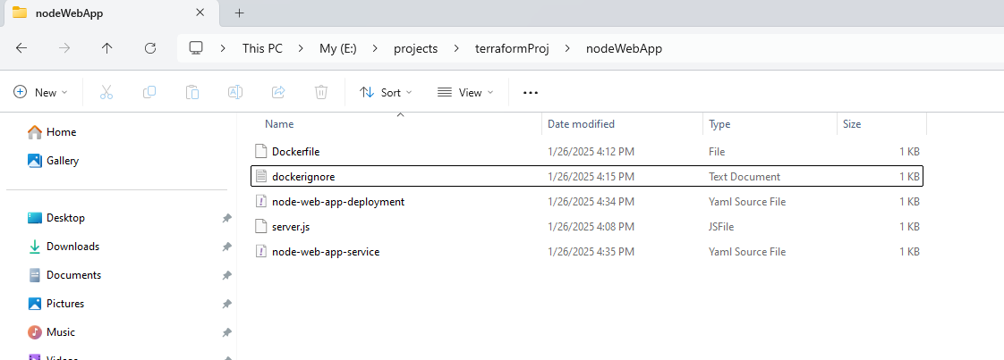

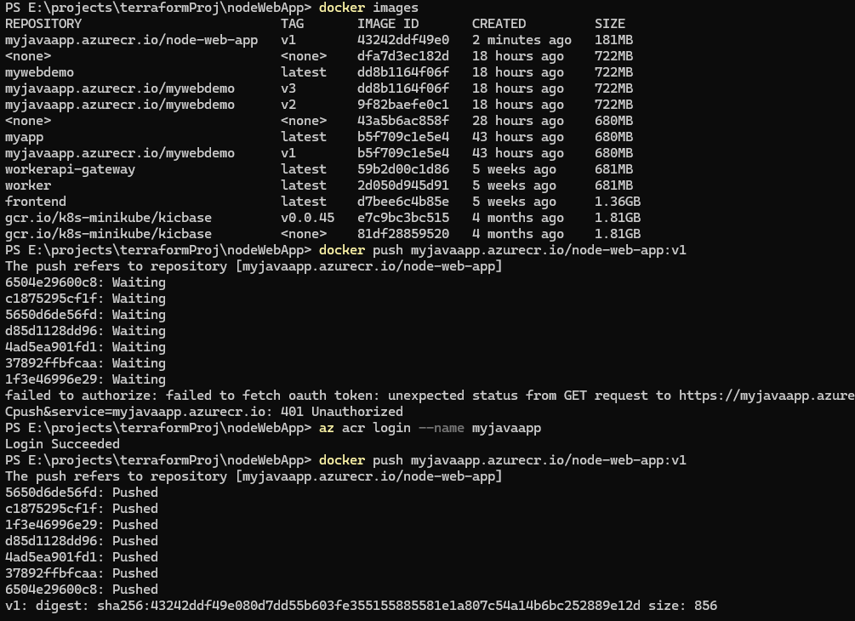

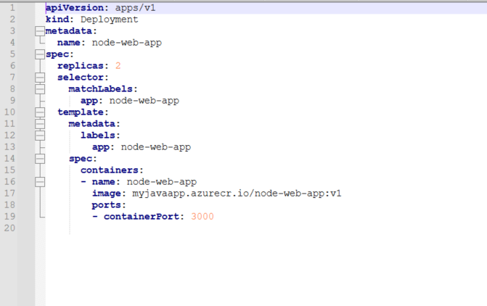

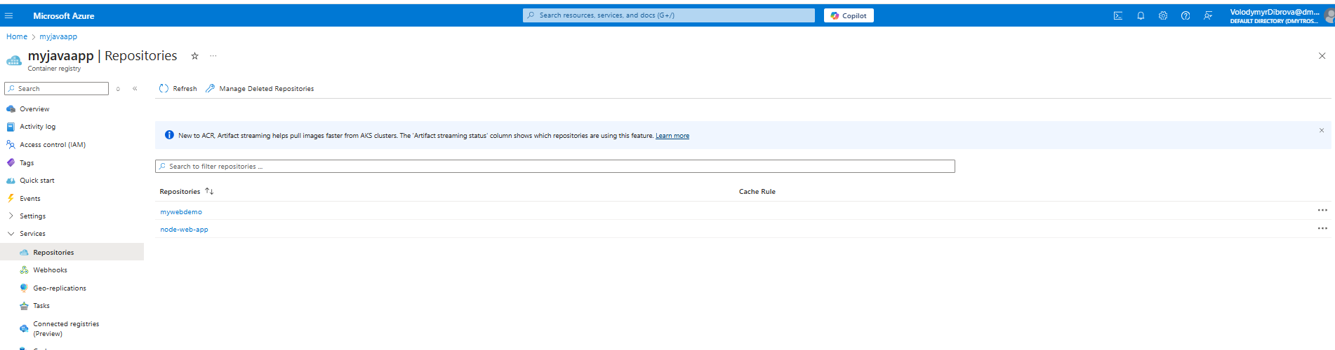

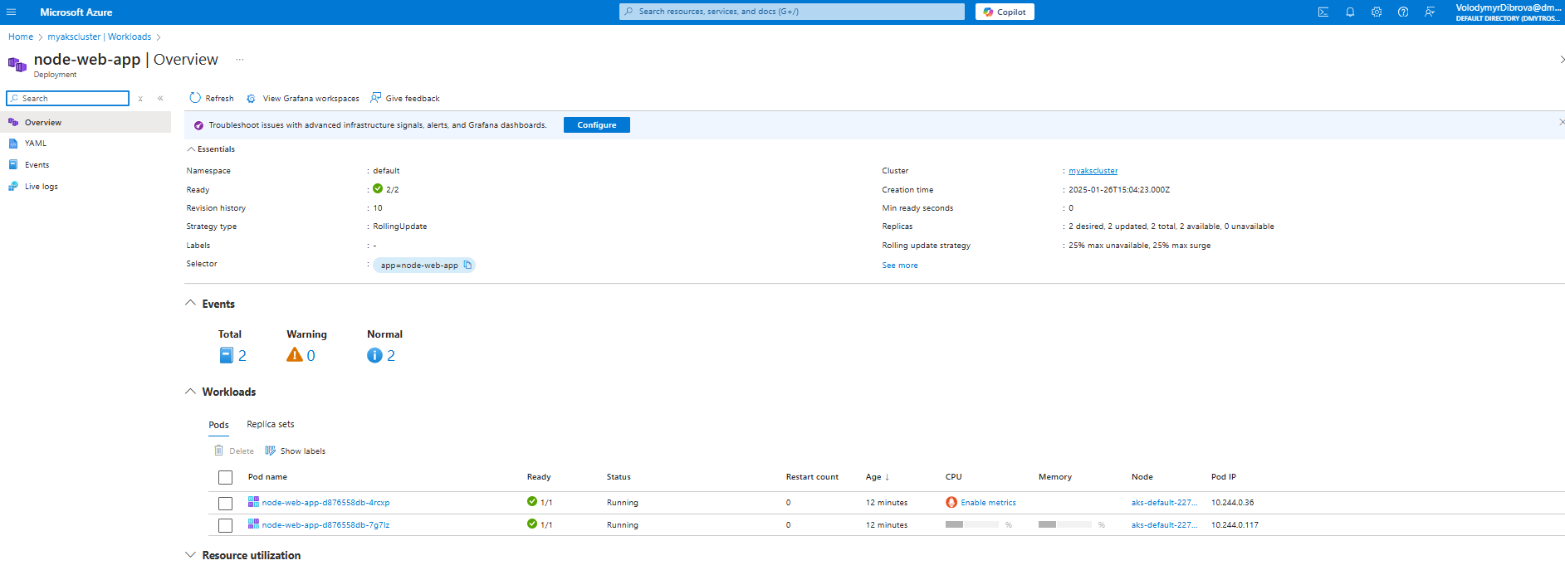

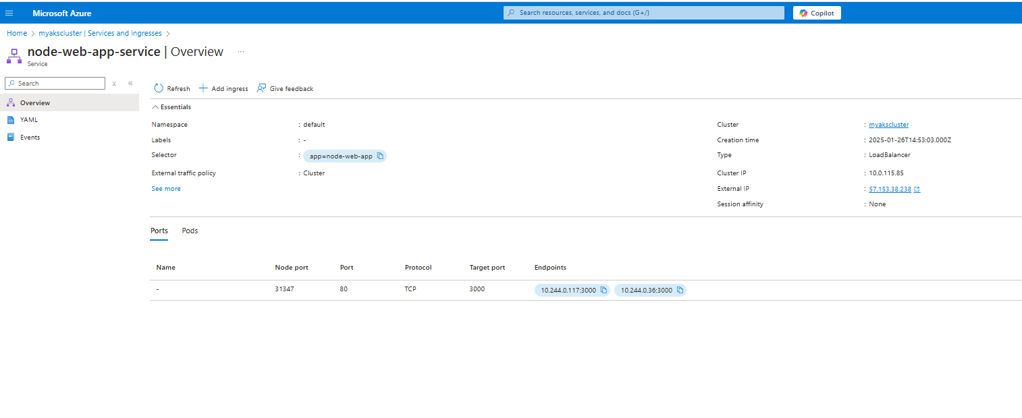

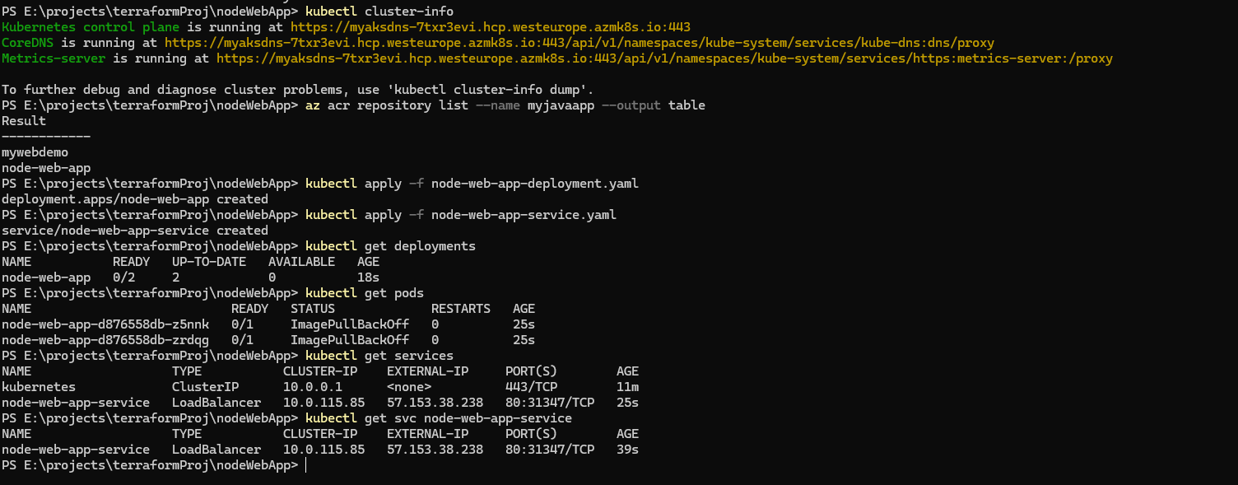

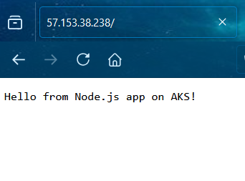

**Practical Task 7: Configure and Use ConfigMaps and Secrets in AKS**

**Requirements:**

1. Create a ConfigMap to store non-sensitive configuration data with only the required key

value pairs for the application.

2. Create a Kubernetes Secret to store sensitive data (e.g., API keys) with the least amount of

information needed.

3. Update the application deployment to use the ConfigMap and Secret.

4. Remove the ConfigMap, Secret, and deployment after testing.

****Actions Taken:****

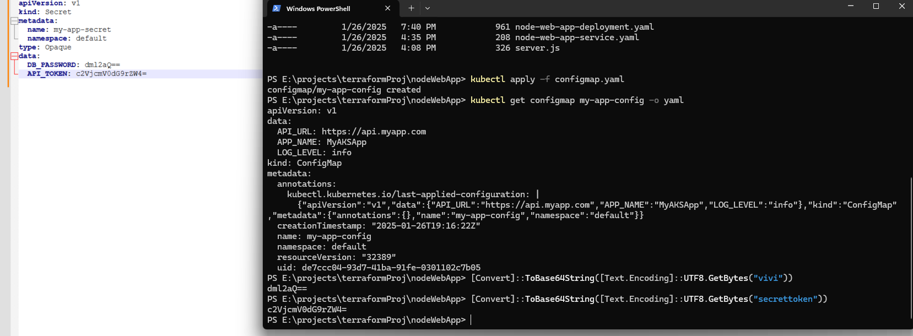





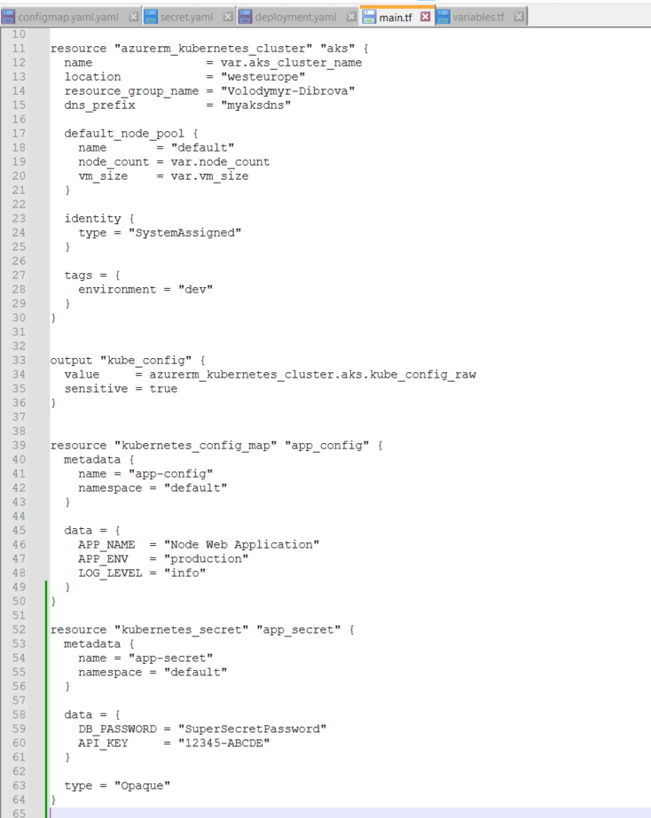

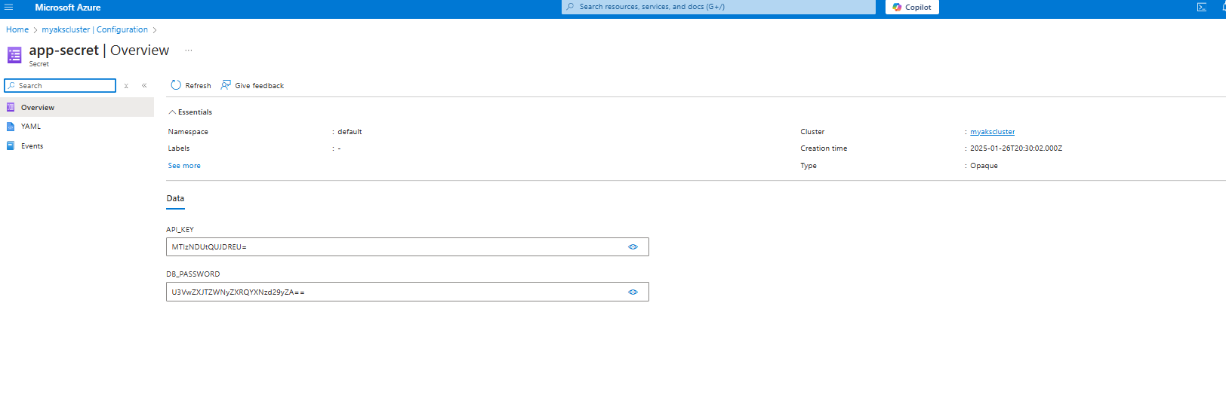

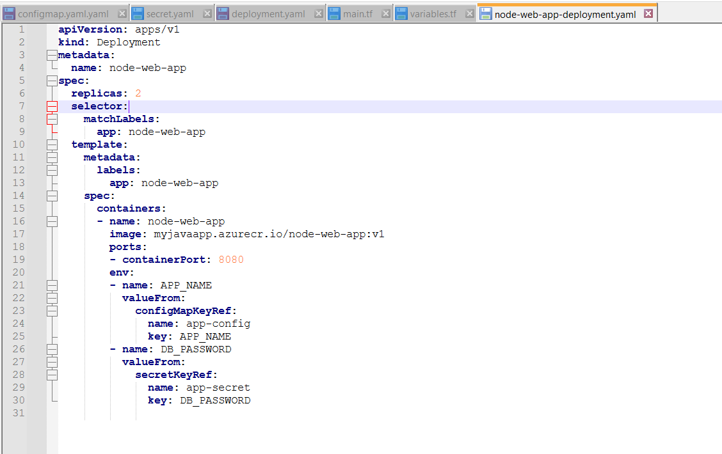

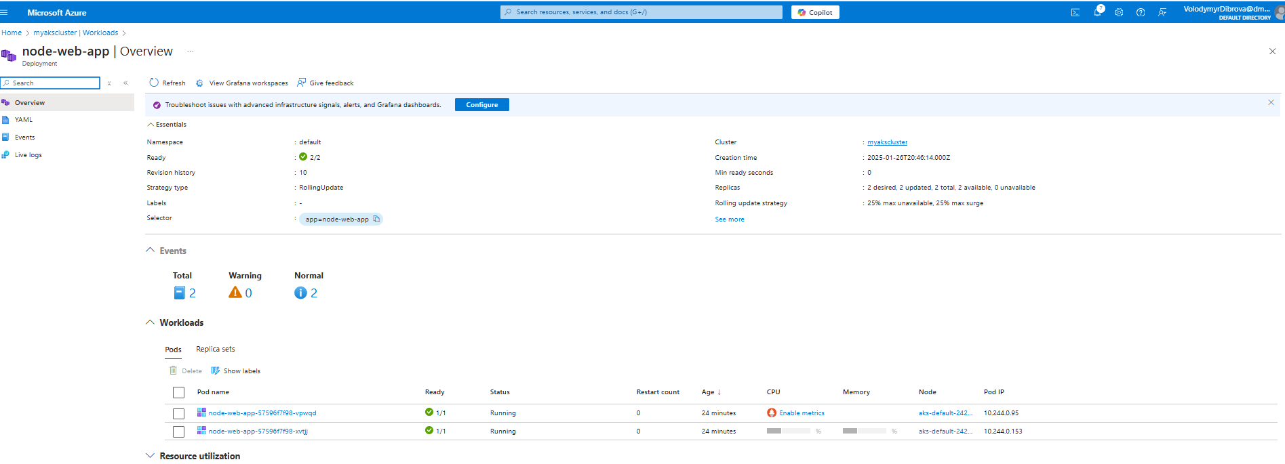

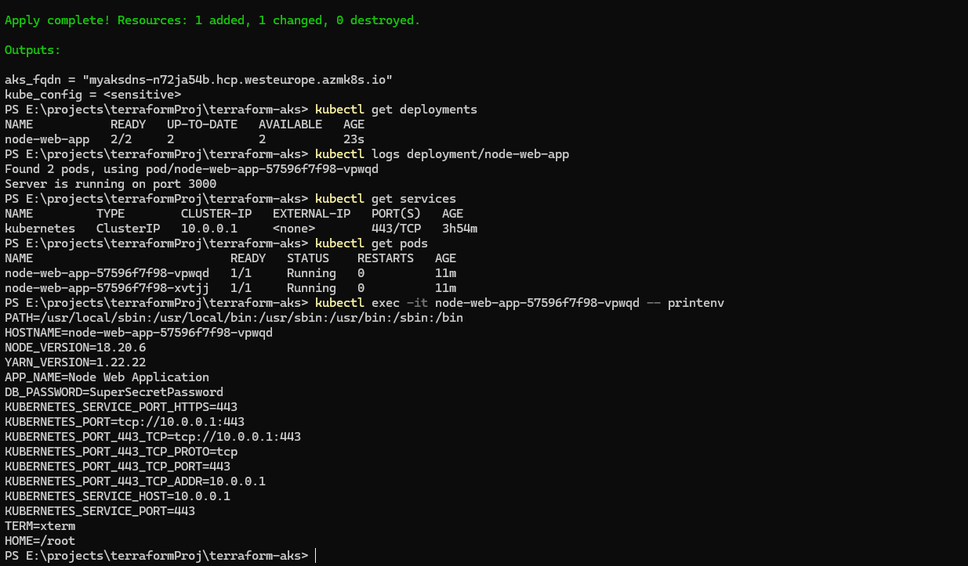



**8**.**Practical Task 8: Scale Applications in AKS**

**Requirements:**

1. Deploy a stateless application to the AKS cluster using minimal resource specifications.

2. Use the kubectl scale command to manually scale the application to only 2–3 replicas for

testing.

3. Set up Horizontal Pod Autoscaler (HPA) with reasonable CPU usage thresholds to minimize

pod creation.4. Simulate load on the application for a short duration and remove the deployment after

observing the scaling behavior

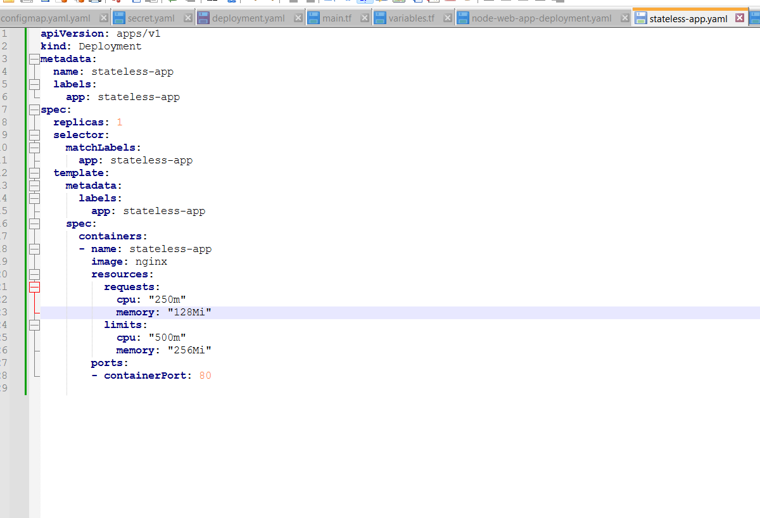

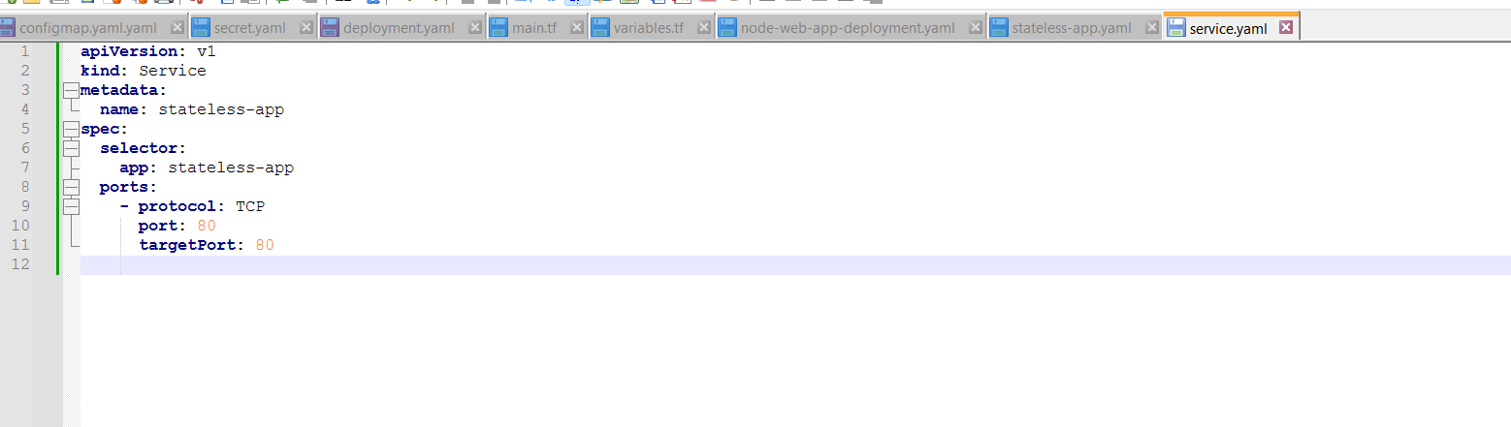

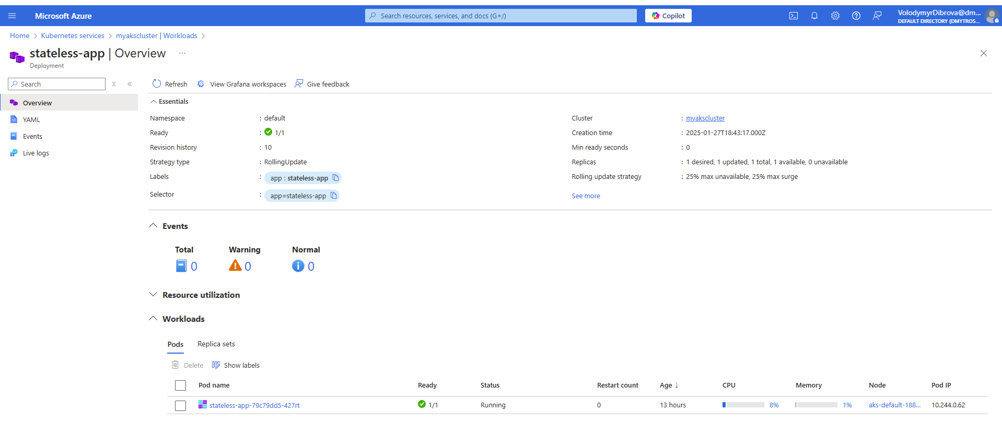

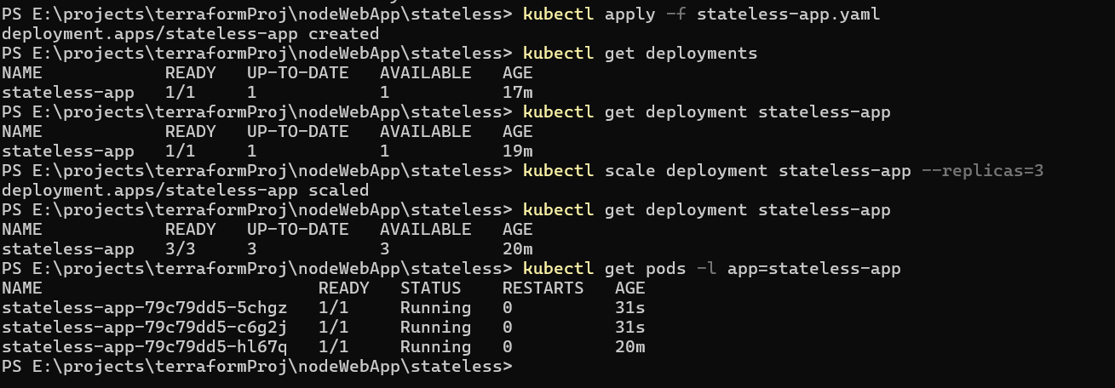

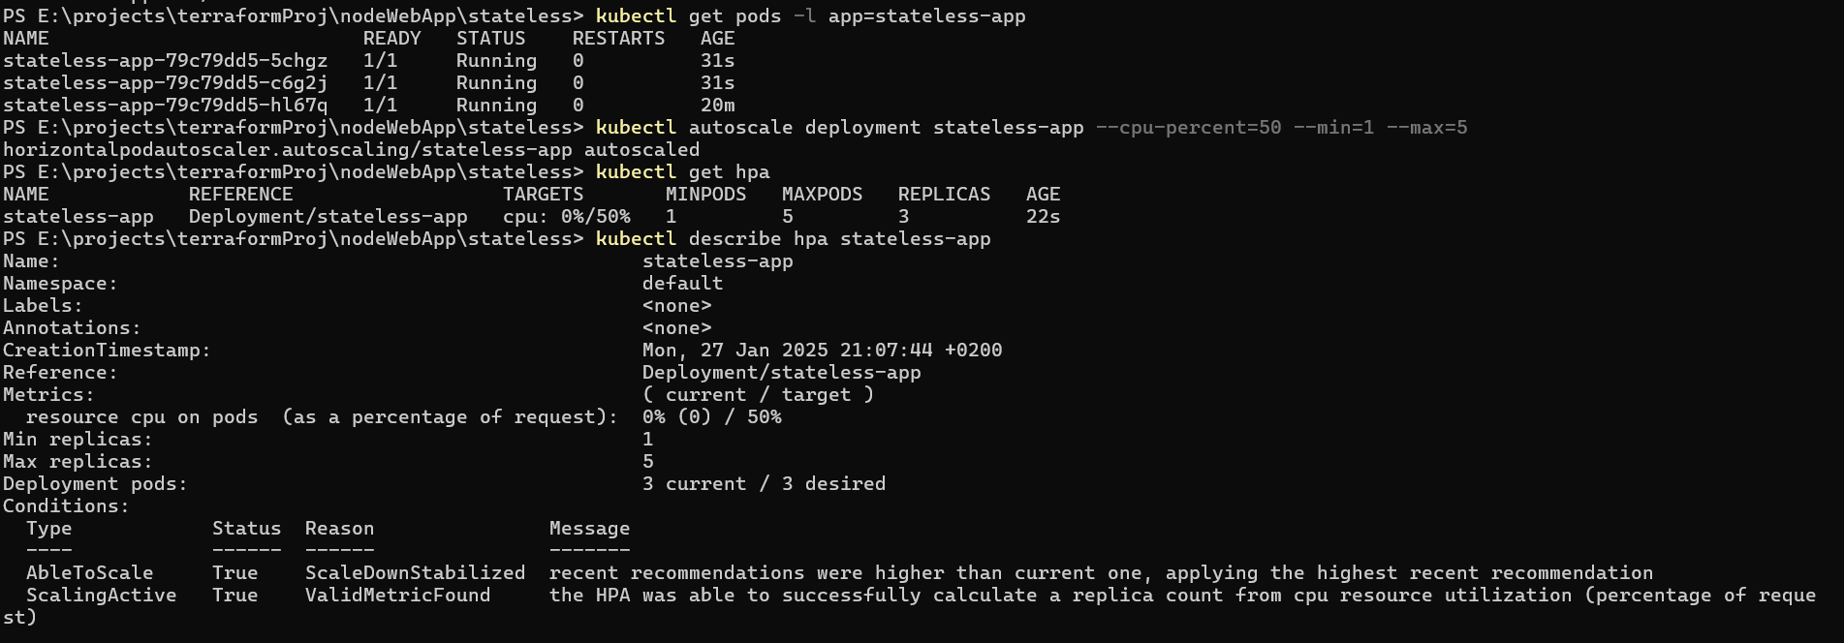

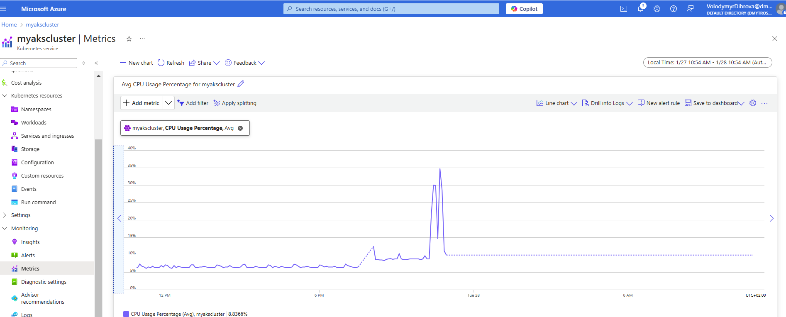

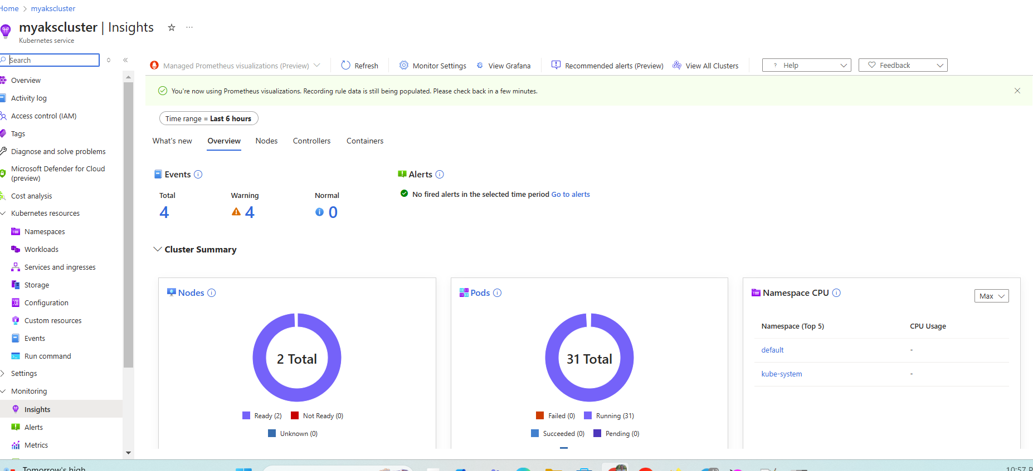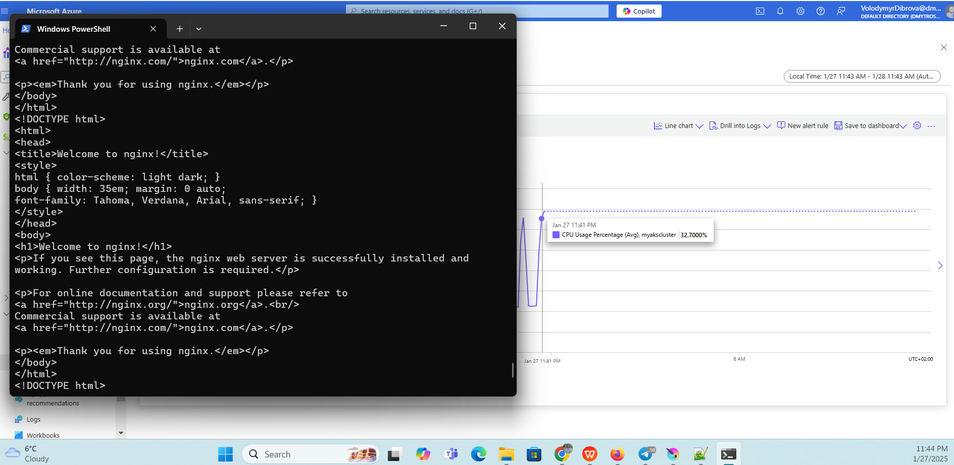

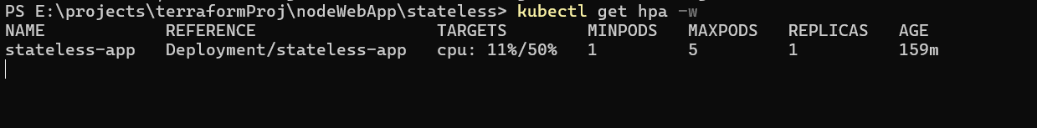

load generation on pods



Autoscaler monitoring



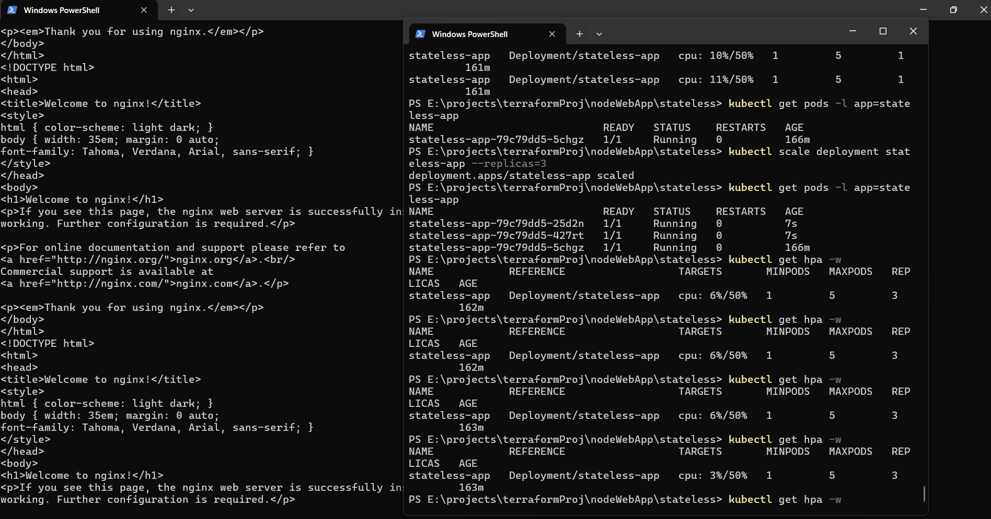

**Practical Task 9: Rolling Update of an Application in AKS**

**Requirements:**

1. Deploy a lightweight version of your application to the AKS cluster.

2. Update the Docker image to a new version with minimal changes (e.g., color change).

3. Perform a rolling update using kubectl set image with minimal replicas to reduce resource

usage.

4. Verify the update process quickly and remove the deployment after the update.

1.Created a YAML file for deployment, service, and docker image with v1

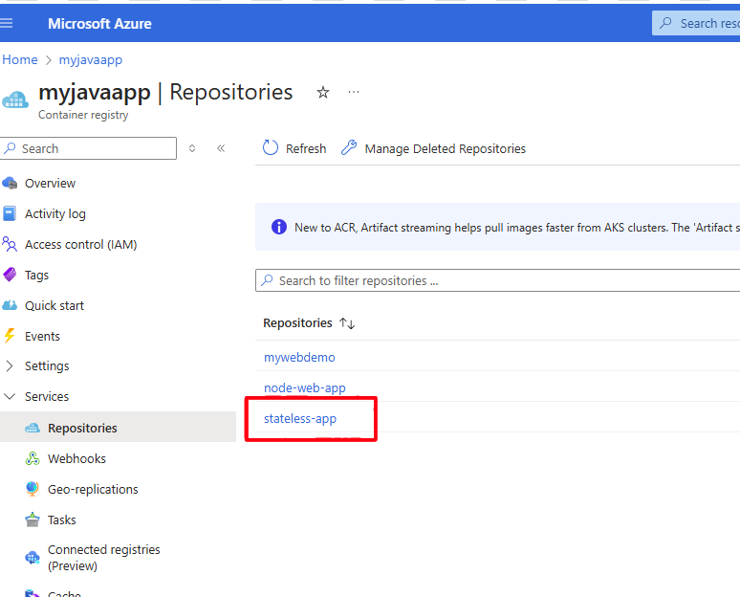

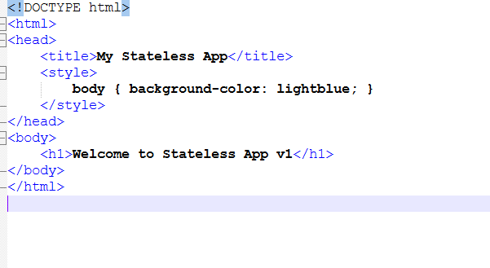

2.Launched the service and opened external-IP in bowser

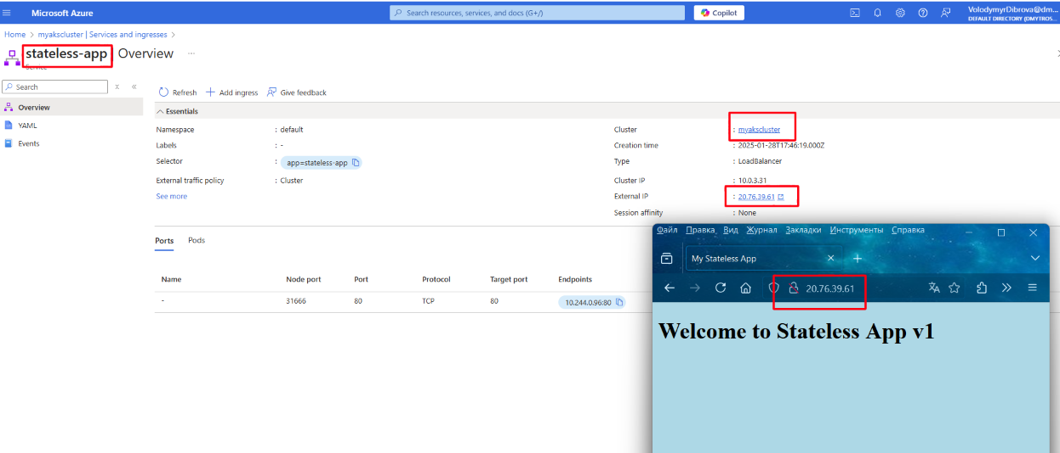

3.Created a new version of the image (v2) with minimal changes - updated body color to yellow

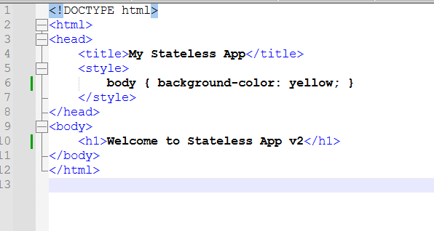

4.Performed a rolling update

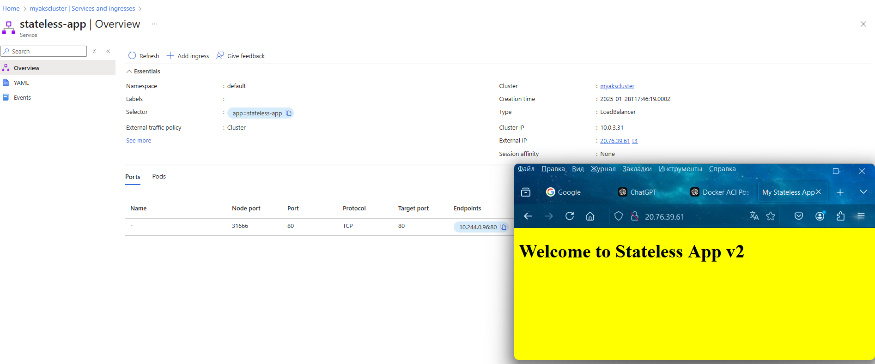

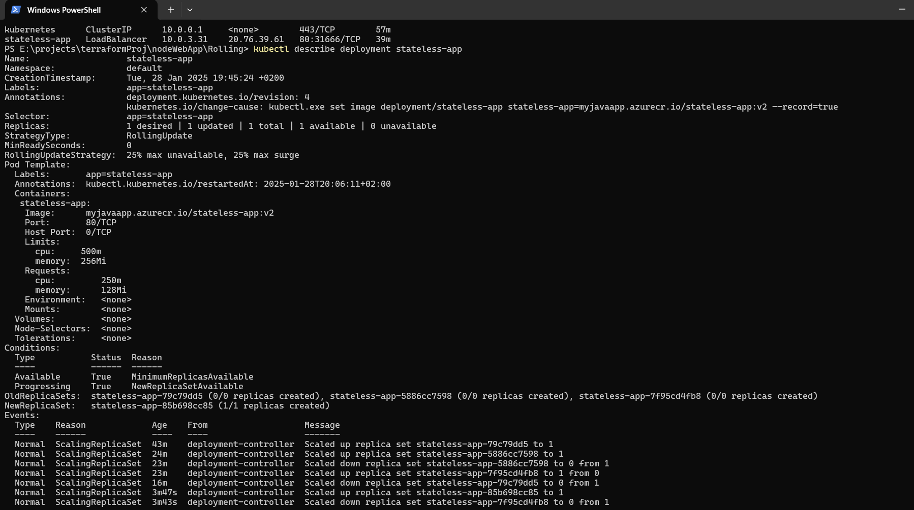

10:Bonus task. **GitOps with AKS Requirements:**

1. Setup ArgoCD on Azure Kubernetes Services

2. Perform image update on cluster

### ****Actions Taken:****

1. Created a namespace for ArgoCD and Installing ArgoCD in AKS

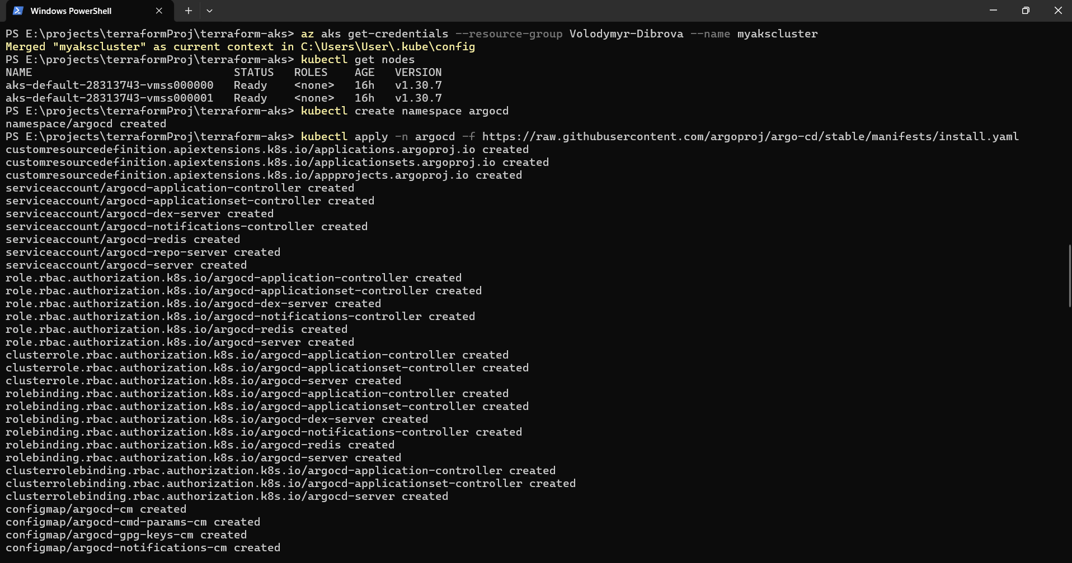

2.Temporary access via port-forward

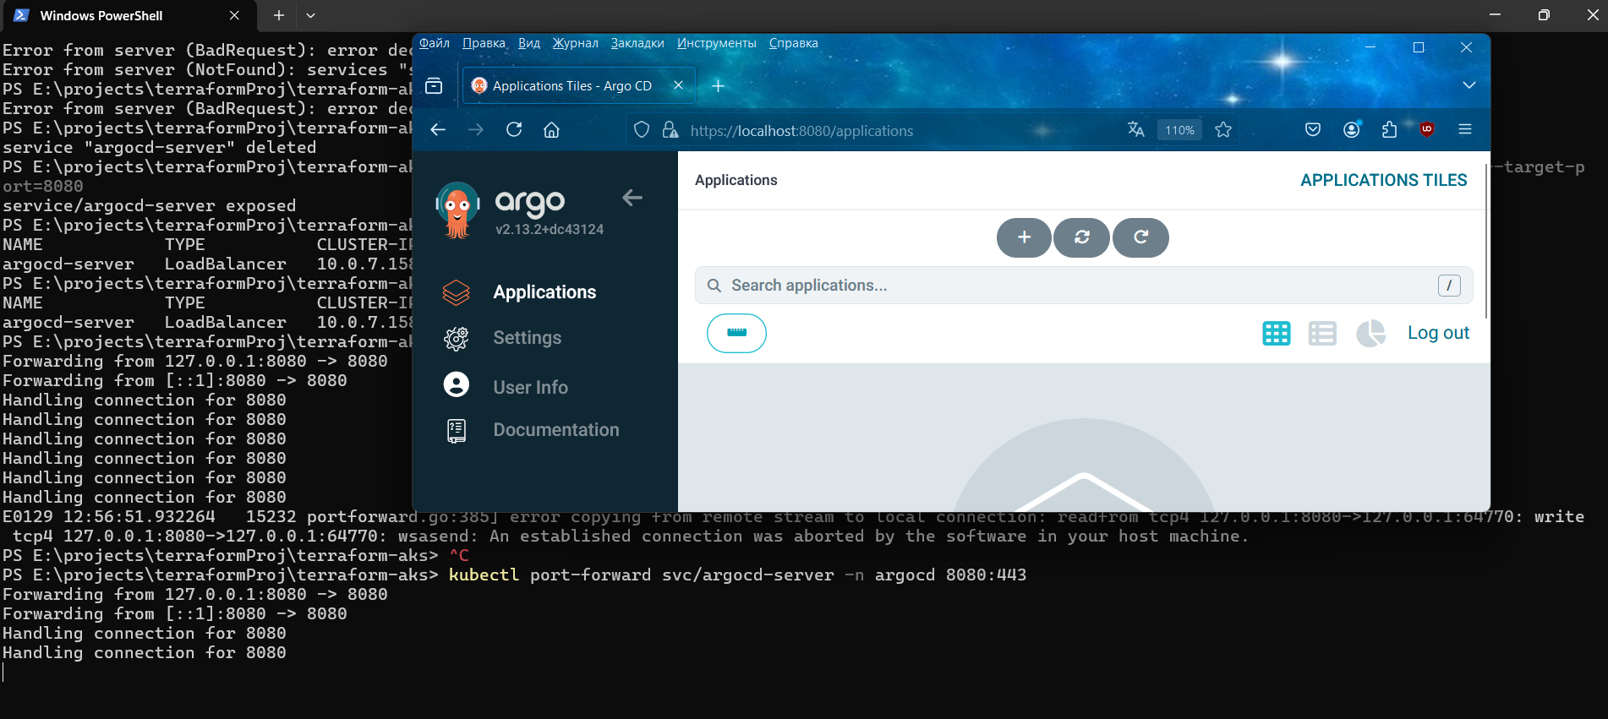

3.Deleted the old srvice and created new sevice LoadBalancer

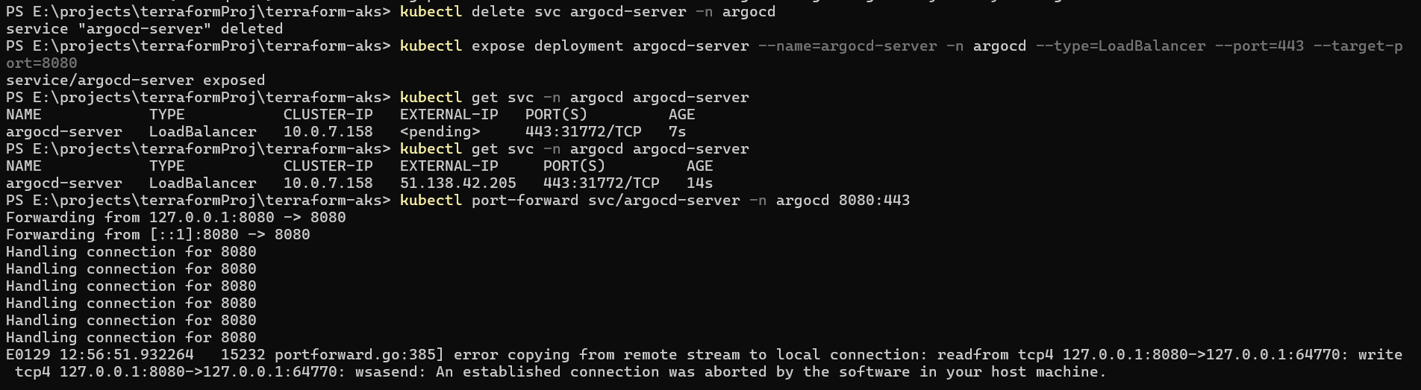

1. Open with external ip:

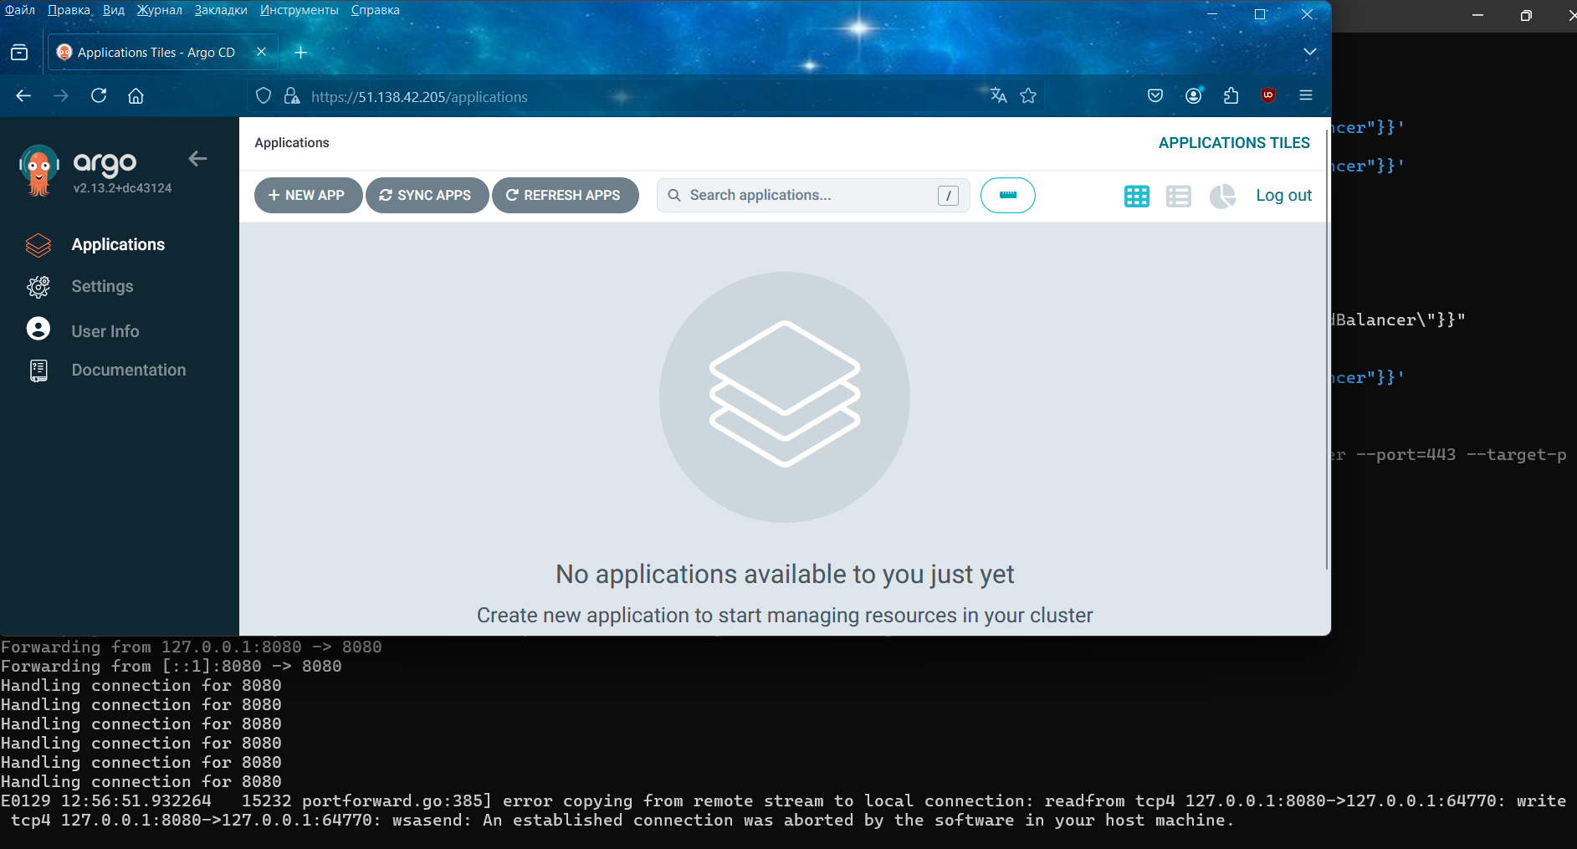

1. connect CLI to ArgoCD server

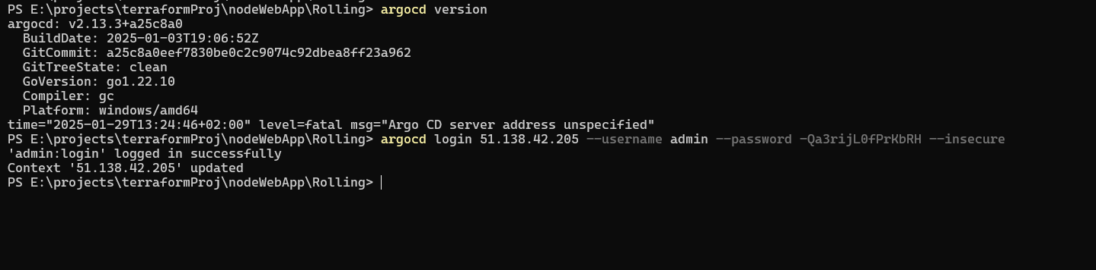

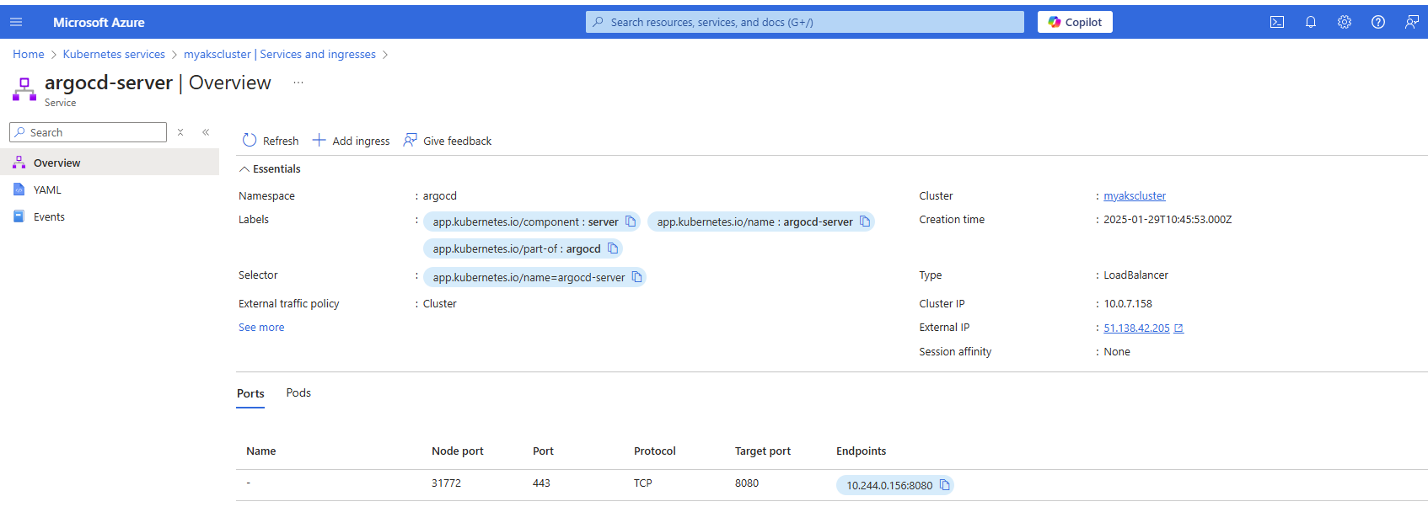

1. synch in gitops

